**Prof.V.B.Shah Institute of Management & R.V.Patel College of Commerce (Eng.Med.) &V.L.Shah College of Commerce (Guj.Med.) &**

**Sutex Bank College of Computer Applications & Science, Amroli**

**(Accredited ‘B’ (CGPA 2.55) by NAAC Dec.-2009)**

# VEER NARMAD SOUTH GUJARAT UNIVERSITY, SURAT



**PROJECT REPORT**

**ON**

### Vaccination Center System

**AS A PARTIAL REQUIREMENT FOR THE DEGREE**

**OF**

**BACHELOR OF COMPUTER APPLICATION**

**(B.C.A.)**

SUBMITTED BY: GUIDED BY:

Tejani Rutvik B. Dr. Shalini A. Mali

Vaghasiya Jaydip M.

Zalavadiya gaurav R.



**Certificate**

This is to certify that the project titled “Marriage Stuff on Rent” is the bonafide work carried out by **Tejani Rutvik B., Vaghasiya Jaydip M., Zalavadiya Gaurav R.**  Students of TYBCA Sem-VI of Sutex Bank Collegeof Computer Application and Science, Amroli, Surat affiliated to Veer Narmad South Gujarat University. He/She has successfully completed his/her project work in partial fulfillment of the requirements for the award of the degree of **“Bachelor of Computer Application”** during the academic year 2021-2022.And that the project has not formed the basis for the award previously of any other degree, diploma, fellowship or any other similar title.

_______________________________

_______________________________

**Dr. Shalini A Mali**

**Dr. Mukesh Goyani**

Project Guide

**Date:**

**Place:** Amroli, Surat.

Principal

**ACKNOWLEDGEMENT**

Accomplishment Requires the effort of many people and this work is no different. As we stride towards the completion of our 6 semester training project, we would like to grab this opportunity to express our deep sense of gratitude towards each and every institution and person who knowingly or unknowingly was part of this project and contributed to its success.

Also, we would like to express our heartfelt gratitude towards our internal guide **Dr. Shalini A Mali** for her invaluable help, critical suggestions and key directions throughout the course of the project. Their in-depth knowledge and experience has always been a constant of inspiration.

We take rather special privilege of thanking our respected principal **Dr. Mukesh Goyani.**

All the faculties for making the resource available within the institute for the project work.

Our special thanks go to our parents, Friends, Colleagues, Batch mates and well-wishers for providing the much needed support and constant motivation for working dedicatedly over this project. Finally we would like to especially thank all those who contributed directly or indirectly to the accomplishment of this project in some way or the other.

**Thank You to All.**

**Tejani Rutvik B.**

**Vaghasiya Jaydip M**

**Zalavadiya Gaurav R.**

**INDEX**

|  |  |  |  |
| --- | --- | --- | --- |
|  |  | **Chapter** | **Page No.** |
|  |  | |  |
| **1.** | **Introduction** | |  |
|  | 1.1 | Project description | 3-5 |
|  | 1.2 | Project Profile |  |
|  |  | |  |
| **2.** | **Environment Description** | |  |
|  | 2.1 | Hardware and Software Requirements | 6-13 |
|  | 2.2 | Technologies Used |  |
|  |  | |  |
| **3.** | **System Analysis and Planning** | |  |
|  | 3.1 | Existing System and its Drawbacks |  |
|  | 3.2 | Feasibility Study | 14-18 |
|  | 3.3 | Requirement Gathering and Analysis |  |
|  |  | |  |
| **4.** | **Proposed System** | |  |
|  | 4.1 | Scope |  |
|  | 4.2 | Project modules | 19-23 |
|  | 4.3 | Module vise objectives/functionalities Constraints |  |
|  | 4.4 | Expected Advantages |  |
|  |  | |  |
| **5.** | **Detail Planning** | |  |
|  | 5.1 | Data Flow Diagram / UML |  |
|  | 5.2 | Process Specification / Activity Flow Diagram | 24-44 |
|  | 5.3 | Data Dictionary |  |
|  | 5.4 | Entity-Relationship Diagram / Class Diagram |  |
|  |  | |  |
| **6.** | **System Design** | |  |
|  | 6.1 | Database Design |  |
|  | 6.2 | Directory Structure | 45-68 |
|  | 6.3 | Input Design |  |
|  | 6.4 | Output Design |  |
| **7.** | **Software Testing** | | **60-70** |
|  |  | |  |
| **8.** | **Limitations and Future Scope of Enhancements** | | **71-72** |
|  | **References** | |  |

**1**

Chapter

**Introduction**

1.1 Project Description

1.2 Project Profile

**1.1 Project Description**

* Vaccination is a simple, safe, and effective way of protecting you against harmful diseases, before you come into contact with them. It uses your body’s natural defenses to build resistance to specific infections and makes your immune system stronger.
* We have created a vaccination website for our project in which the user can get the vaccine from the vaccine appointment.
* In which the service is provided to the user to get the vaccine from the number of Aadhar card and from the location of his chosen vaccine center.
* Vaccine distribution in the state and city are determined by the admin and also admin and staff who can add and manage the vaccine.
* The staff has indicated that the vaccine user should get his appointment dates.

|  |  |
| --- | --- |
| **Field** | **Description** |
| **Project Title :** | Vaccination center System |
| **Team Members:** | Tejani Rutvik B.  Zalavadiya Gaurav R.  Vaghasiya Jaydip M. |
| **Description :** | We developed vaccination center system to provide hustle free services to the end user. |
| **Front-End :** | HTML,CSS,BootStrap,Javascript,jquery,  ,Ajax |
| **Back-End :** | ASP.NET Core MVC |
| **Technology :** | Window 10 |
| **Tools :** | Visual Studio 2019 |
| **Internal Guide :** | Dr. Shalini A. Mali |

**2**

Chapter

**Environment Description**

2.1 Hardware & Software Requirements

2.2 Technologies Used

**2.1 Hardware & Software Requirements**

**Hardware Requirement**

* 1. **Development side:**
     + 4GB RAM
     + Window 10 pro
     + Hard disk 1TB

1. **Server side:**
   * + 4GB RAM
     + Window 10 pro
     + Hard disk 1TB
2. **Client side:**

* + - 4GB RAM
    - Window 10 pro
    - Hard disk 1 TB

**Software Requirement**

1. **Development side:**

* Window 10 pro

1. **Server side:**

* SQL Server 2014

**Operating System:**

* Window 10 pro

1. **Client side:**

* Google Chrome, Mozilla Firefox

**2.2 Technologies Used**

* **Front End :**
  + **CSS:**

**Cascading style sheets** (CSS) is a W3C standard for defining the presentation of web document. Presentation refers to the way a document is displayed or delivered to the user, whether it is on a computer monitor. A cell phone display, or read aloud by a screen reader. This book focuses primarily on the visual aspects of presentation, such as typography, colors, alignment, layout, and so on. CSS is the mechanism for providing these types of style instructions to element in a document that has been marked up with XHTML, HTML, or any XML language. Most important, CSS keeps these presentations separate from the content and its structural and semantic markup.

* **The Benefits Of CSS:**
  + **Greater typography and page layout controls**

With style sheets, you can specify traditional typography features that you could never do with HTML alone (even with its presentational extensions).

* + **Less Work**

Not only can format all similar elements in a document with a single style rule, external style sheets make it possible to edit the appearance of an entire site at once with a single style sheet edit.

* + **Potentially smaller documents**

Redundant font tags and nested tables make for bloated documents. Stripping Presentational HTML out of the document save on file size

* + **JQuery:**

JQuery is a cross-browser JavaScript library designed to simplify the Client side scripting of HTML. It was released in January 2006 at Bar Camp NYC by John Resign. Used by over 55% of the 10,000 most visited website, JQuery is the most popular JavaScript library in use today.

JQuery is free, open source software, dual-licensed under the MITLicense or the GNU General Public License, Version 2.jquery’s syntax is designed to make it easier to navigate a document, select DOM elements, create animations, handle events, and develop Ajax applications. The modular approach to the JQuery library allows the creation powerful dynamic web pagesand web application.

* + **JAVA SCRIPT**

Java script is a programming language that can be included on web pages to make them more interactive. You can Use it to check or modify the content of forms, change images. Open new widows and write dynamic page content. You even use it with CSS to make DHTML. This allows you make parts of your web pages appear or disappear or move around on the page.

JavaScript is a client side, interpreted, object oriented, high level scripting language, while Java is a client side, compiled, object oriented high level language.

* + **AJAX :**

The terms Ajax is used to describe a set of technology that allows browsers to provide users with a more natural browsing experience. Before Ajax, Web sites forced there users into the submit/wait/redisplay paradigm, Where the users action were always synchronize with the server’s “think time”. Ajax provides the ability to communicate with the server asynchronously, thereby freeing the user experience from the request/response cycle. With Ajax, when a user clicks a button, you can use JavaScript and DHTML to immediately update the UI, and spawn an asynchronous request returns, you can then use JavaScript and CSS to update the UI accordingly without referencing the entire page. Most importantly, user don’t even know your code is communicating with the server, the web site feels like it’s instantly responding.

* + **BOOTSTRAP**

Bootstrap is the most popular HTML, CSS, and JS framework for developing responsive, mobile first projects on the web. It would be easy to send you over to their Getting Started page and call it a day. Their setup guide is indeed a host of useful information - links to CDNs, explanations on how to install with Bower, npm, and Composer, information on integration with Autoprefixer and LESS, a bunch of templates, licenses, and translations.

* + **HTML**

HTML (HyperText Markup Language) is **the code that is used to structure a web page and its content**. For example, content could be structured within a set of paragraphs, a list of bulleted points, or using images and data tables. It is used to design web pages using a markup language. HTML is the combination of Hypertext and Markup language. Hypertext defines the link between the web pages. A markup language is used to define the text document within tag which defines the structure of web pages.

* **Extra Technologies :**
  + **Visual studio 2019 :**

Visual Studio 2019 was released on April 2nd, 2019. There are so many advanced features. Visual Studio is one of the most famous IDE’s has been using for the last few years. Microsoft developed it. It is used to create a computer program, web applications, and EXE files, etc. The first version of its kind was launched in 1997.

Visual Studio 2019 introduces exciting improvements and new features aimed at optimizing developer productivity and team collaboration.

ASP .NET supports three major development models: web pages, web forms, and MVC (model view controller). ASP .NET MVC frame-work is a lightweight, highly testable presentation framework that is integrated with the existing ASP .NET features, such as master pages, authentication, etc. Within NET this framework is defined in the System. Web. MVC assembly. The latest version of the MVC framework is 5.0. We use visual studio to crate ASP NET MVC application which can be added as template in visual studio.

* **Back End :**

* **Overview of SQL Server 2014 :**

SQL Server 2014,the latest complete information platform from Microsoft, embodies the new era of Microsoft ‘s Cloud OS,which provides organizations and customers with one consistent platform For infrastructure,apps and data that span customer data centres hosting service provider data centres and Microsoft public cloud. The benefits that customer experience with a consistent platform includes common development, management, data, identity, and virtualization, no matter where an application is being run.

* **Asp.net core MVC :**

ASP.NET Core MVC is a rich framework for building web apps and APIs using the Model-View-Controller design pattern.

The Model-View-Controller (MVC) architectural pattern separates an application into three main groups of components: Models, Views, and Controllers. This pattern helps to achieve separation of concerns Using this pattern, user requests are routed to a Controller which is responsible for working with the Model to perform user actions and/or retrieve results of queries. The Controller chooses the View to display to the user, and provides it with any Model data it requires.

The ASP.NET Core MVC framework is a lightweight, open source, highly testable presentation framework optimized for use with ASP.NET Core.

ASP.NET Core MVC provides a patterns-based way to build dynamic websites that enables a clean separation of concerns. It gives you full control over markup, supports TDD-friendly development and uses the latest web standards.

ASP.NET Core MVC is built on top of ASP.NET Core's routing a powerful URL-mapping component that lets you build applications that have comprehensible and searchable URLs. This enables you to define your application's URL naming patterns that work well for search engine optimization (SEO) and for link generation, without regard for how the files on your web server are organized. You can define your routes using a convenient route template syntax that supports route value constraints, defaults and optional values.

Microsoft SQL Server 2014 is the next generation of Microsoft’s information platform, with new features that deliver faster performance, expand capabilities in the cloud, and provide powerful business insights.

* + **Component of MVC :**

**Model**

**Controller**

**View**

**3**

Chapter

**System Analysis and Planning**

3.1 Existing System and its Drawback

3.2 Feasibility Study

3.3 Requirement Gathering and Analysis

**3.1 Existing System and its Drawback**

* **Existing System:**

Managing all the vaccine data with the help of paper will include a lot of paper work. Earlier systems manually add the inventory of particular vaccines which was making complex job and it leads to create mismanagement and due to this phenomenon, number of vaccine shot expired without uses which were waste of money.

In earlier system, people who want to take a vaccine, it was necessary to go at the particular vaccine center and book an appointment. Sometime vaccine slot was finish and people don’t able to take vaccine shot after book an appointment, which was time consuming for them.

It is also true that many website are available to book an appointment for vaccine but it works in limited vaccine type.

* **Drawback/limitation of existing system :**

Each and every system has certain drawbacks that lead them into improper working or the same traditional manual system of keeping all paper based record system and it can be more tedious to use in some way.

* Following are the drawbacks of the existing system that are observed and which forced us to design new system.
* Data Maintaining
* Security of Data
* Time Consuming
* Lots of Registration
* Lack of immediate Retrievals
* Lack of immediate information storage
* Lack of prompt Updating
* Preparation of accurate and prompt reports

**3.2 Feasibility Study**

**Introduction:**

A feasibility study is a one of the significant pillar of project because the company and their management want to ensure that any system they plan to develop is actually “feasible” or not .it is also help to introduce necessary equipment and services so we can arrange all of it before the timeline and do work without hustle.

* **Technical Feasibility**
* **Economical Feasibility**
* **Operational Feasibility**
* **Time Feasibility**
* **Technical Feasibility :**
* This Website Does Require That Much of Higher & Advanced Technology. It requires Database interaction and it also requires to be accessed via web or Internet.
* Technical feasibility study is the complete study of the project in terms of input, processes, output, fields, programs and procedures
* **Economical Feasibility:**
* In This Project, We Will Require To Have An Internet Connection For Better Online Website.
* Such at the developer end It needs the good server with high capacity of RAM and CPU Processors So can It can handle lots of members at time Online Communications , But as It will be Web - enabled We do not have any extra cost of setting up a network.
* **Operational Feasibility:**
* Test of operational feasibility asks if the website will work where it is developed and installed.
* As well as this website does not cause any harm to the other application, and can also be implemented in - phase with the other website.
* System provides the users friendly interface which helps new users to book an appointment in the website.
* The proposed system made best efforts in achieving necessary function and performance as required by the user and keep in mind some infrastructure constraints.
* **Time Feasibility:**
* Time feasibility describes the time cost for converting the existing system to new system.
* As an aspect of time feasibility our system takes Two months for completion.
* This system is Develop under the time period of just Two months with proper validation so we can say that this system is time feasible.

**3.3 Requirement Gathering and Analysis**

* **Requirement Gathering :**
* Different types before developing an elegant software, best way to identify basic needs and functionality for proposed application. By analysing the information we understand following process requirement for system.
* Vaccine in available City, center, and state information can be obtained through the available stock and Staff profiles are added delete and update details by admin.
* Maximum user appointment book of the day is done so that systems overload stops on Websites Lake and provide reliable services.
* Allocate the same dose as the appointment booked by the staff.
* **Requirement Analysis :**
* We analyse our gathered information and we have decided our system should have following functionalities:
* **It creates patient account**
* **It deletes patient account**
* **Authorization of patient Account**
* **Update patient account**
* **Download vaccination certificate**

**4**

Chapter

**Proposed System**

4.1 Scope

4.2 Project Modules

4.3 Module vice objectives / functionalities constraints

4.4 Expected Advantages

**4.1 Scope**

* **Scope of system :**

The current project Vaccination centers have the corresponding

Scope of which is as follows:

* + Information about Patients is done by just writing the Patient aadhar card number. Whenever the Patient comes up his information is stored freshly.
  + Diagnosis information to patients is generally recorded on the document, which contains Patient information. It is destroyed after some time period to decrease the paper load in the office.
  + Information about various diseases is not kept as any document. Doctors themselves do this job by remembering various medicines.
  + Certificate of vaccine is generated on the dose of the patient. Certificate is generated when the dose is given by the staff.
* **Aims :**
* Our mission is to bring saving the time of patients and he can take vaccine from the designated location centre.
* To bring more creativity into the Vaccination Centre System.
* Admin who can comfortably view available vaccine and allocate vaccine.

**4.2 Project Modules**

* The vaccination center system has web based applications and in an efficient and convenient way the patient takes the vaccine appointment and allocates the specified location.
* We have developed a system in which different states have their cities and centers so that the patient can easily decide where to get vaccine.
* The certificate of the patient receiving the vaccine shows the location centers and where the staffs is given in the certificate and the record of the patient receiving the vaccine is maintained in the system.
* **Module**

1. **Admin** :

In this module, admin can add, modify, delete and update the Details, Location and various other attributes. Admin Update Profile.

1. **Staff** :

In this module, the staff can see the appointment of the day and the available doses. They have the details of the patient.

1. **Patient/User :**

In this module, User who can book appointment and centers location can determine and download the vaccine certificate.

**4.3 Module vice objectives/functionalities Constraints**

There are various objectives which are both handled on user side as well as on staff side and it became more user friendly as for it also. Allows admin with some specific features .

* **Admin**
* Log In
* Manage User
* Manage Staff
* Allocate Vaccine
* Manage Contact
* Manage Vaccine inventory
* Manage Profile
* Manage Role
* **Staff**
* Login
* Register
* Update Profile
* Give Vaccine based on appointment date
* Notify User
* Authenticate Valid Proof
* **User**
* Login
* Register
* Update Profile
* Contact
* Check Vaccination Status
  + - Book Appointment
    - Download Certificate
  1. **Expected Advantages**
* **High Security :**

There is high security mechanism provided by the proposed system. No unauthorized person can make change in the data those are stored in website. Only authorized person can change and can make login.

* **Less Time Required :**

In our website, all the processes are carried by computer so obviously it will require time than traditional inventory system and in that sense; it will require less time to complete transaction and can process data very fast.

* **High Amount of Accuracy :**

In our web system there are less amount of human activities are involved in that case it will have less effect in our accounts. The website will perform all calculation and manipulation automatically; In that case the data that we receive will be accurate and much more reliable than the generated previously.

* **Easy Registration :**

Users can easily register from this website. Users can easily sign in and out. Admin can easily login and get user or staff details.

**5**

Chapter

**Detail Planning**

5.1 Data Flow Diagram

5.2 Process Specification / Activity Flow Diagram

5.3 Data Dictionary

5.4 Entity-Relationship Diagram / Class Diagram

**5.1 Data Flow Diagram**

**Introduction**

Also known as DFD, Data flow diagrams are used to graphically represent the flow of data in a business information system. DFD describes the processes that are involved in a system to transfer data from the input to the file storage and reports generation.

Data flow diagrams can be divided into logical and physical. The logical data flow diagram describes flow of data through a system to perform certain functionality of a business. The physical data flow diagram describes the implementation of the logical data flow.

* **Symbols used in DFD**
* **External Entity**
* **Process**
* **Data Store**
* **Data Flow**

1. **External Entity :**

An outside system that send or receive data, communicating with the system being diagrammed. They are the sources and destinations of information entering or leaving the system. They might be an outside organization or person, a computer system or a business system. They are also known as terminators, sources and sinks or actors. They are typically drawn on the edges of the diagram.

1. **Process:**

Any process that changes the data, producing an output. It might perform computations, or sort data based on logic, or direct the data flow based on business rules. A short label is used to describe the process, such as “Submit payment.”

1. **Data Store:**

Files or repositories that hold information for later use, such as a database table or a membership form. Each data store receives a simple label, such as “Orders.”

1. **Data Flow**

The route that data takes between the external entities, processes and data stores. It portrays the interface between the other components and is shown with arrows, typically labelled with a short data name, like “Billing details.”

* **0th Level Diagram**

Res. for Download Certificate

Req. for Download Certificate

Res. for Book Appointment

Req. for Book Appointment

Res. for Notify User

Req. for Notify User

Req. forGive Vaccine

Res. for Sign Up

Res. for Sign Up

Res. for login/logout

Req. for Sign Up

Req. for login/logout

Req. for login/logout

Res. for login/logout

Res. for Show Vaccine

Res. for Manage/User Staff

Res. for Allocate/Manage Vaccine

Req. for Allocate/Manage Vaccine

Req. for Show Vaccine

Req. for Manage/User Staff

Req. for login/logout

**Vaccination Center System**

**User**

**Staff**

**Admin**

Req. for Sign Up

Res. For Give Vaccine

Res. for Sign Up

Res. for login/logout

Req. for Sign Up

* **1st Level Diagram**
* **Admin**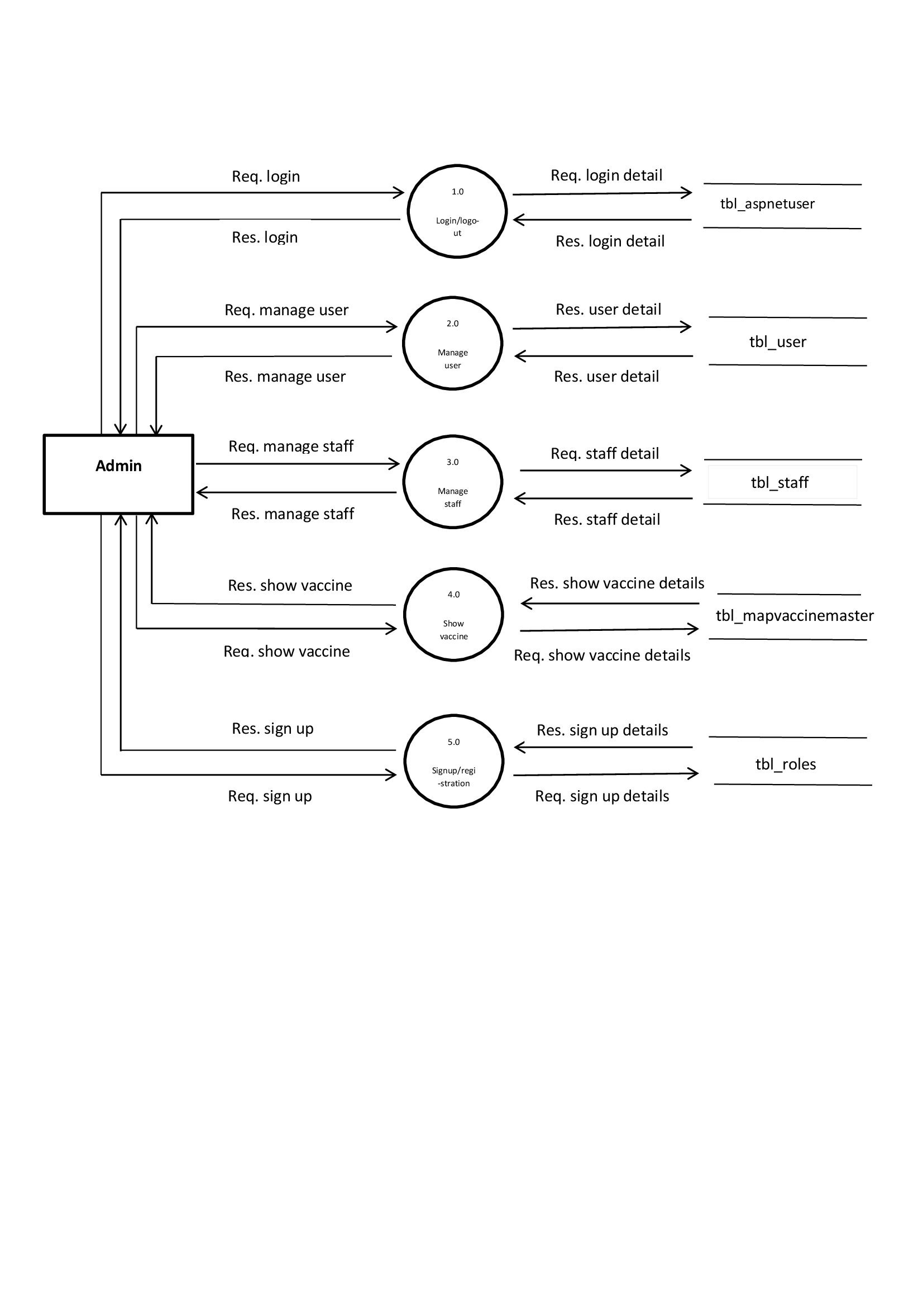

5.0

Sign Up

4.0

Show vaccine

3.0

Manage

Staff

2.0

Manage

User

1.0

Log In / Log Out







* **Staff**

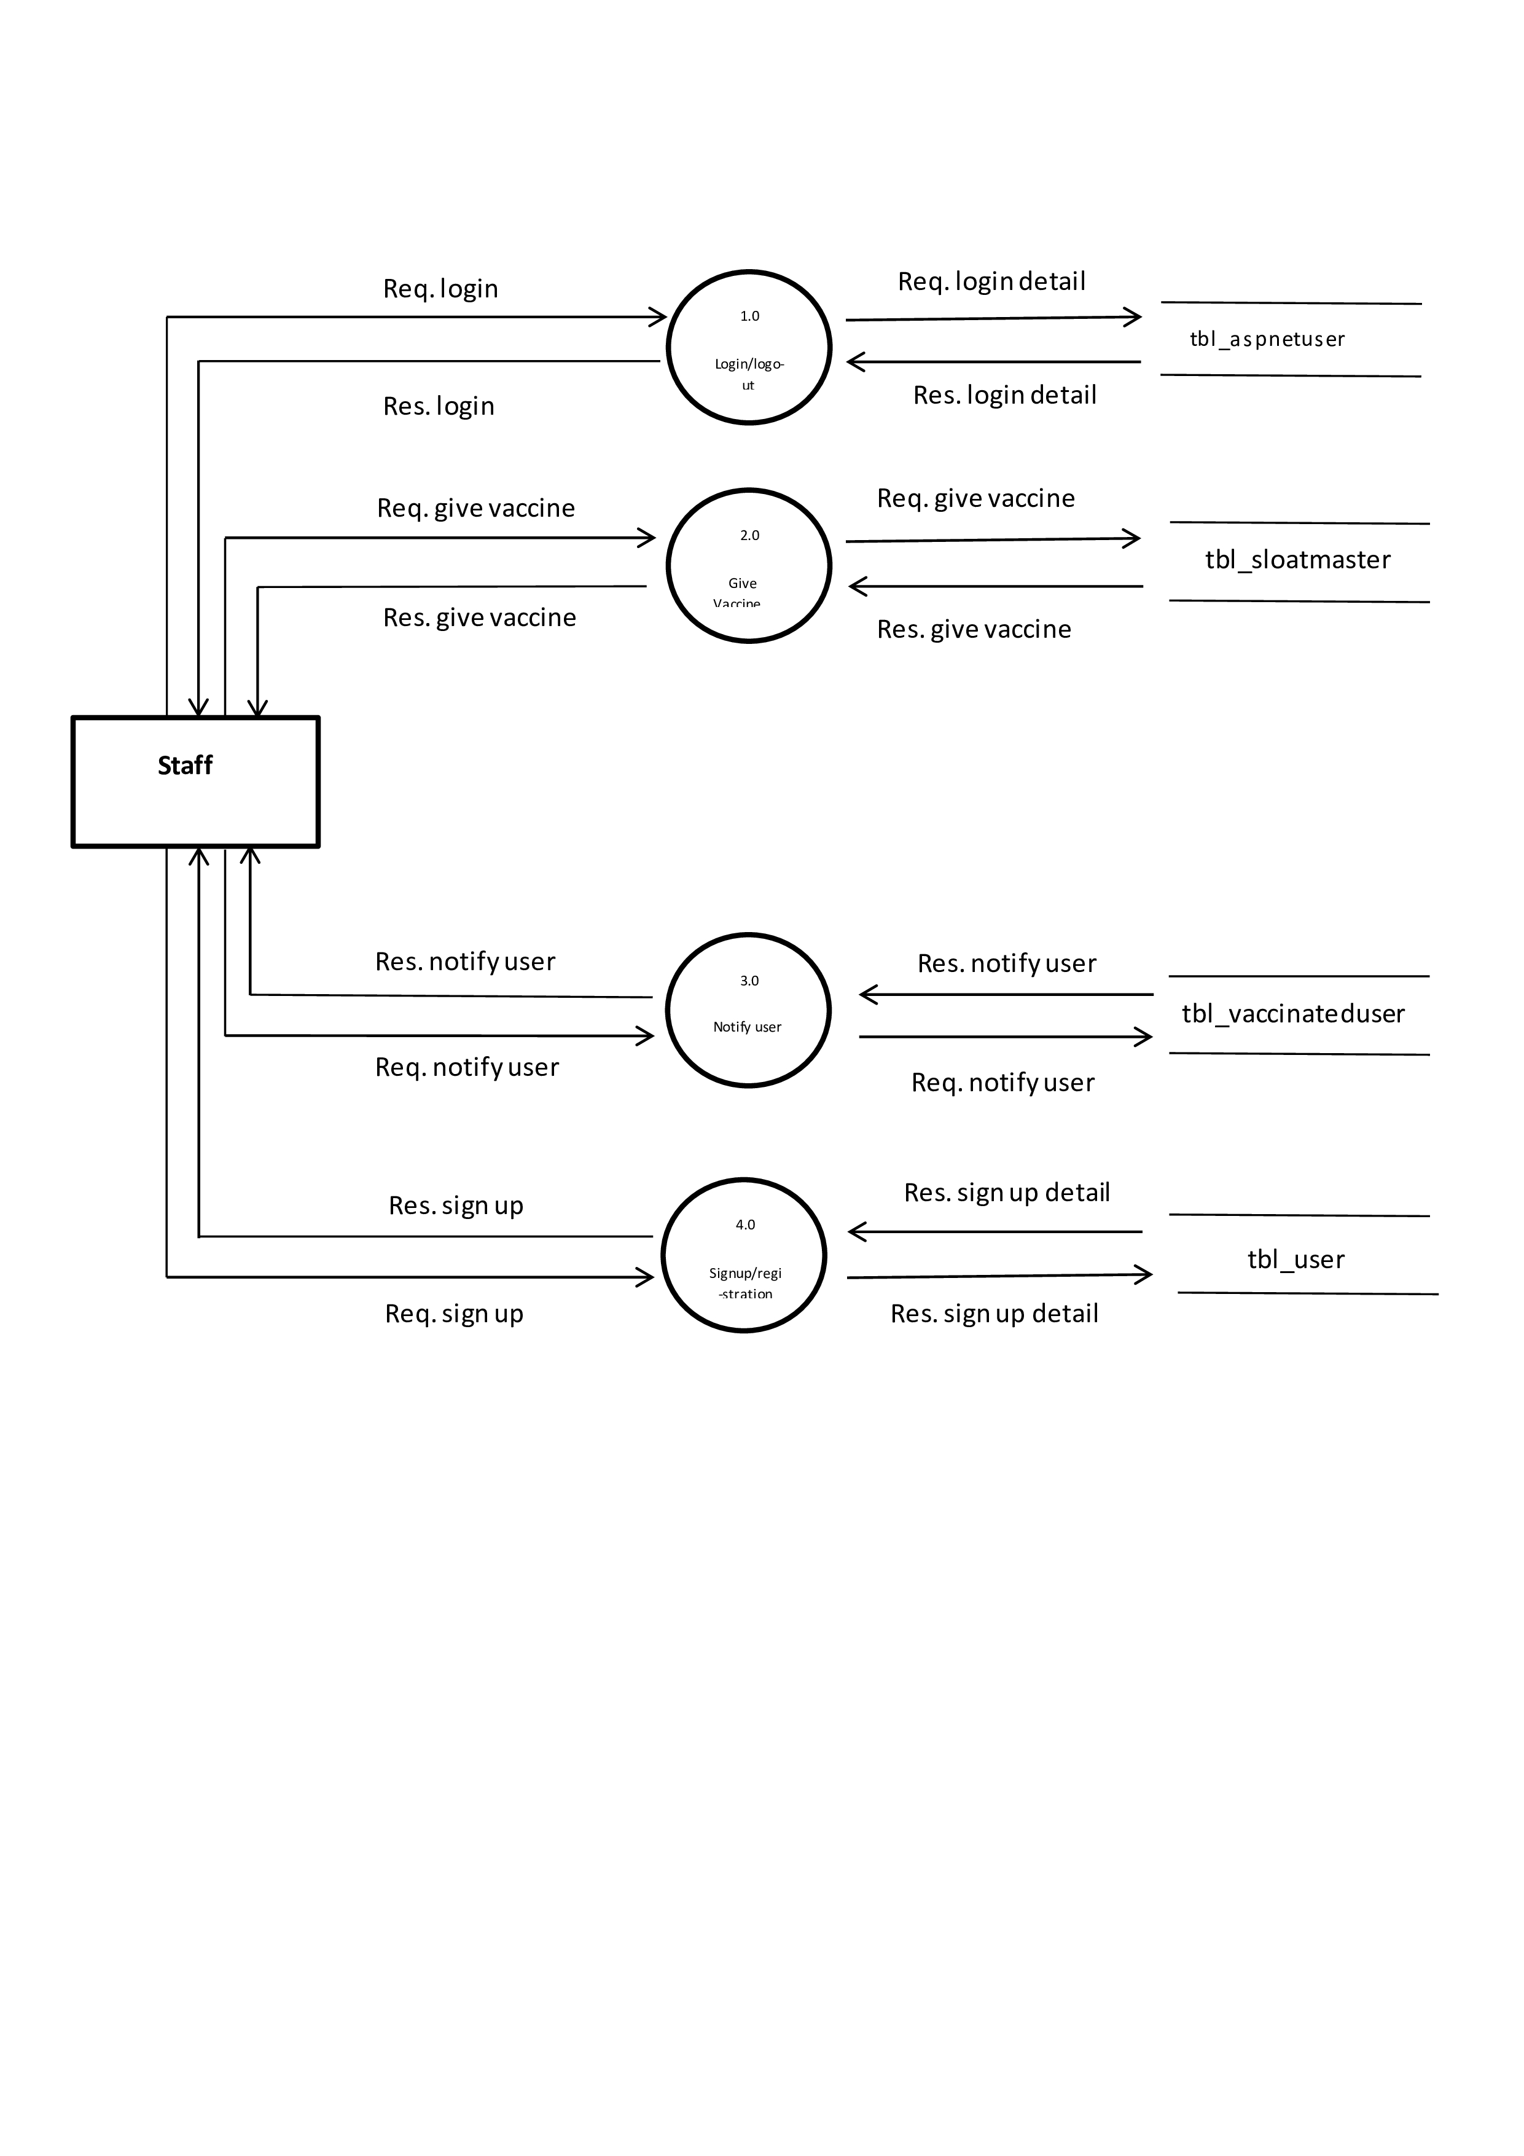

4.0

Sign Up

3.0

Notify User

2.0

Give Vaccine

1.0

Log In

* **User**

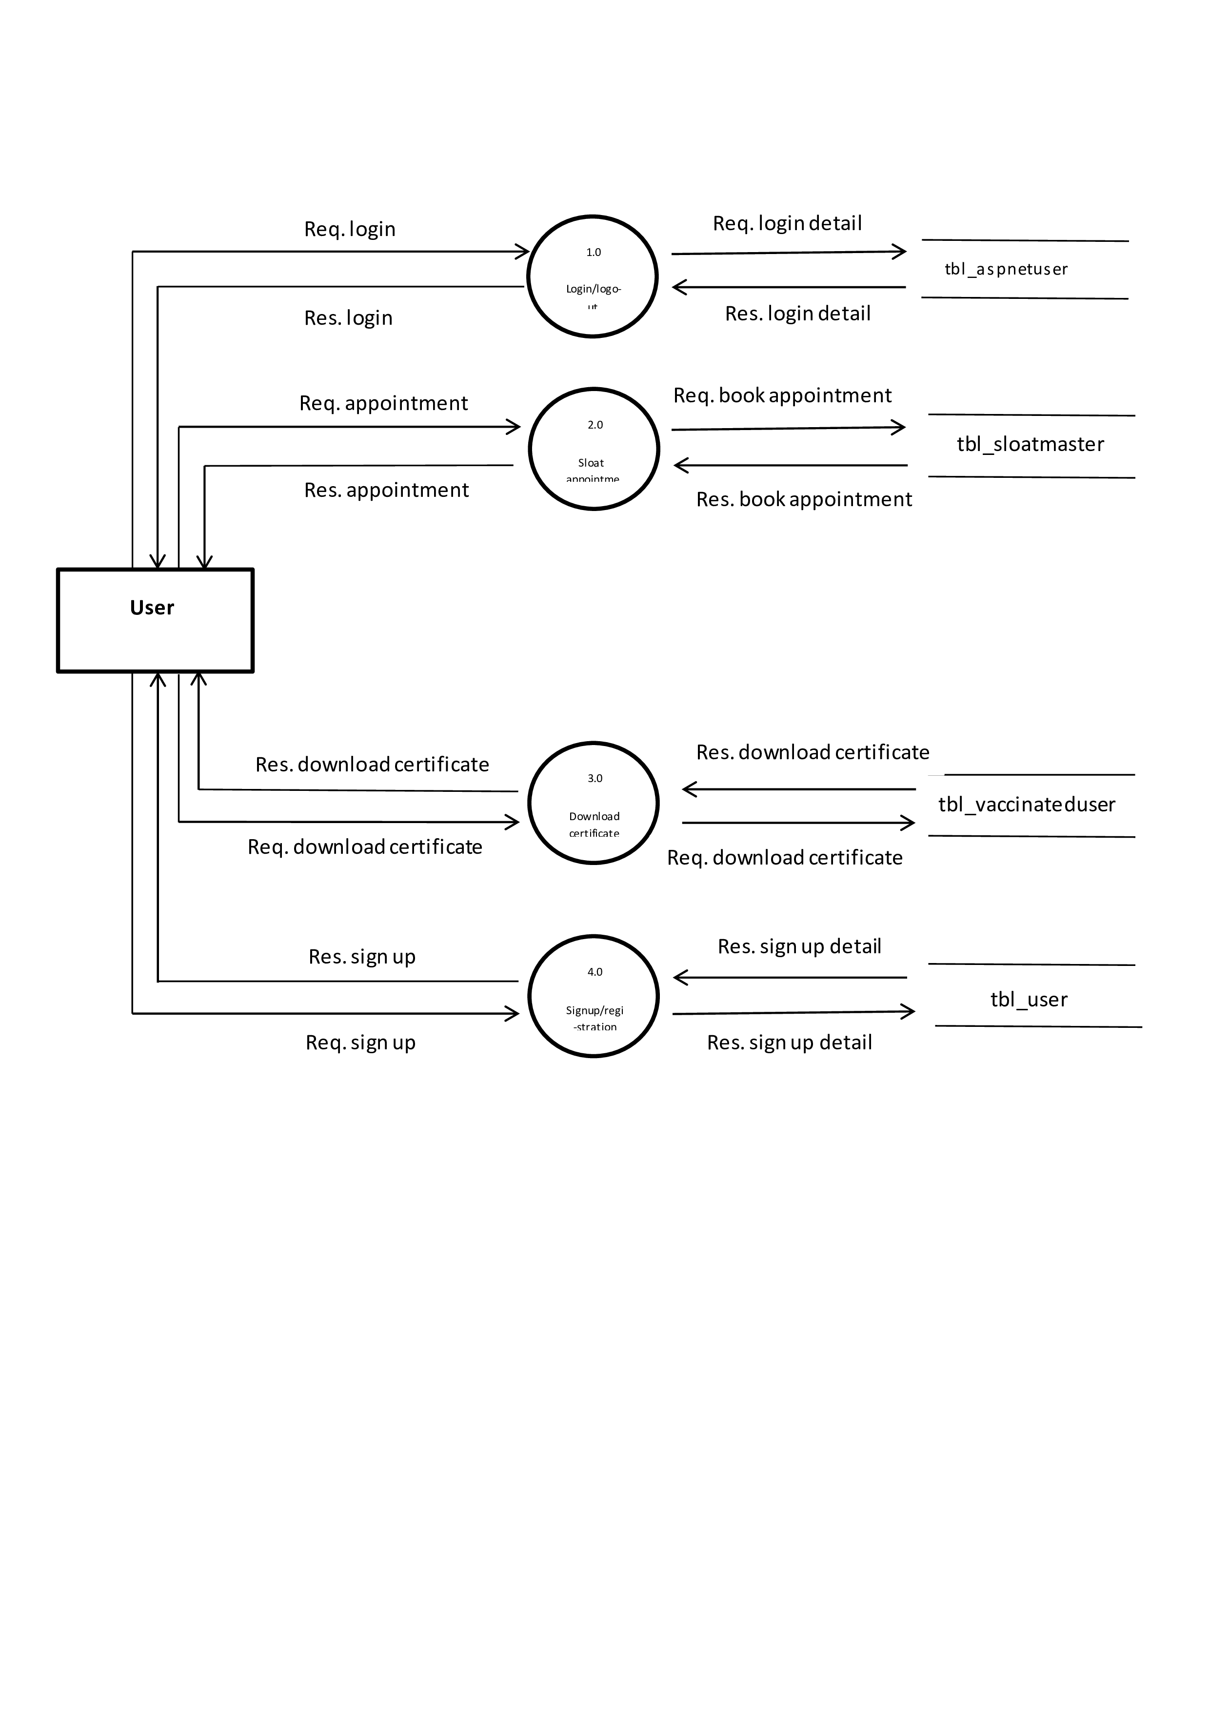

4.0

Sign Up

3.0

Download Certificate

2.0

Book Appointment

1.0

Log In

* **2nd Level Diagram**
* **Admin**

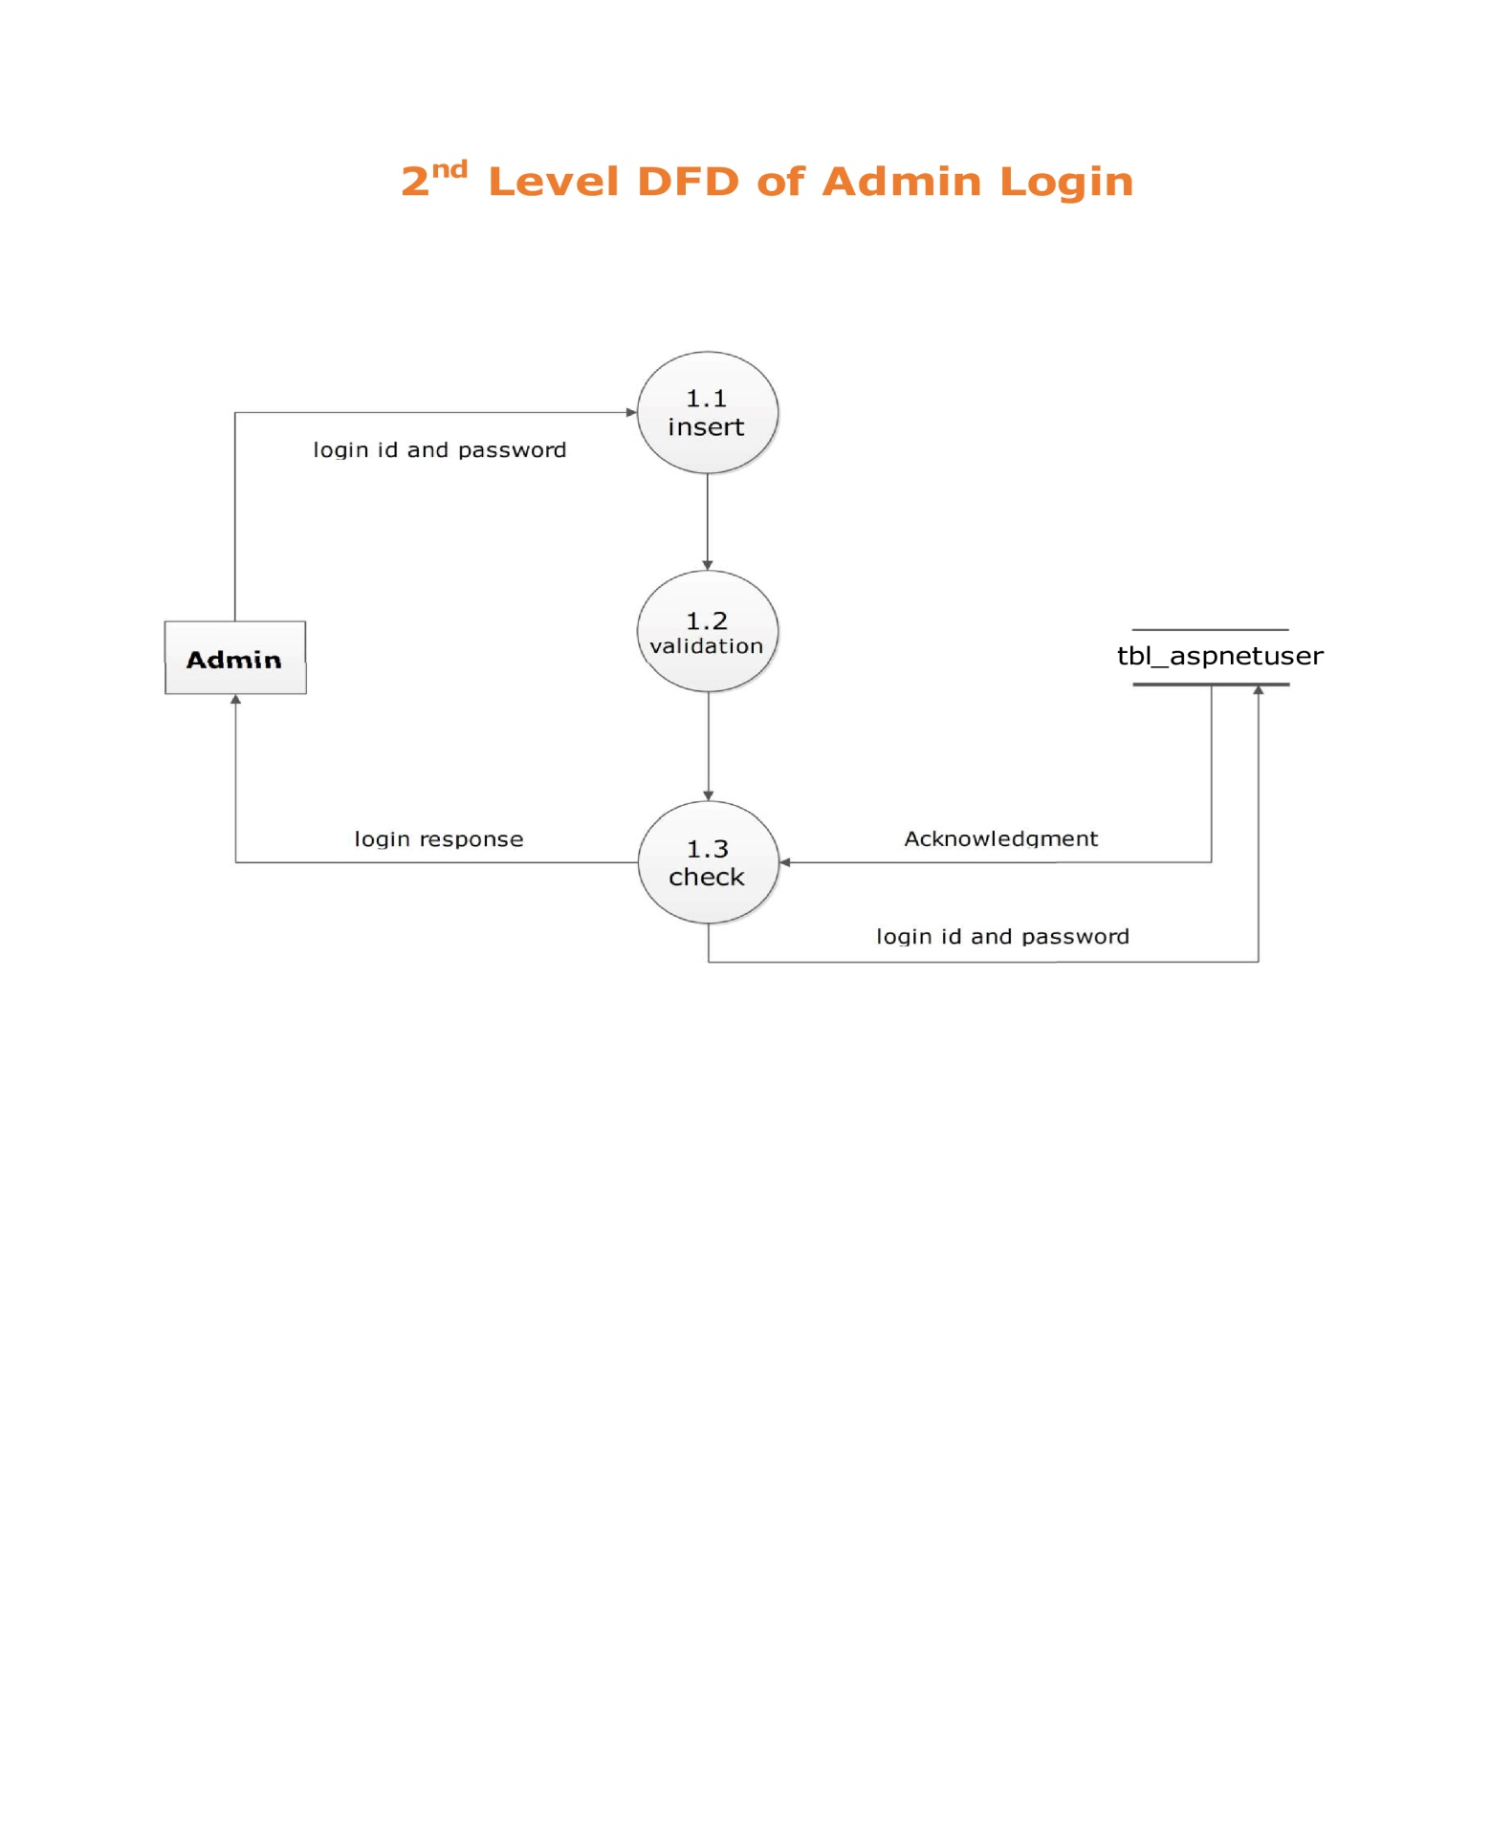

* **User**

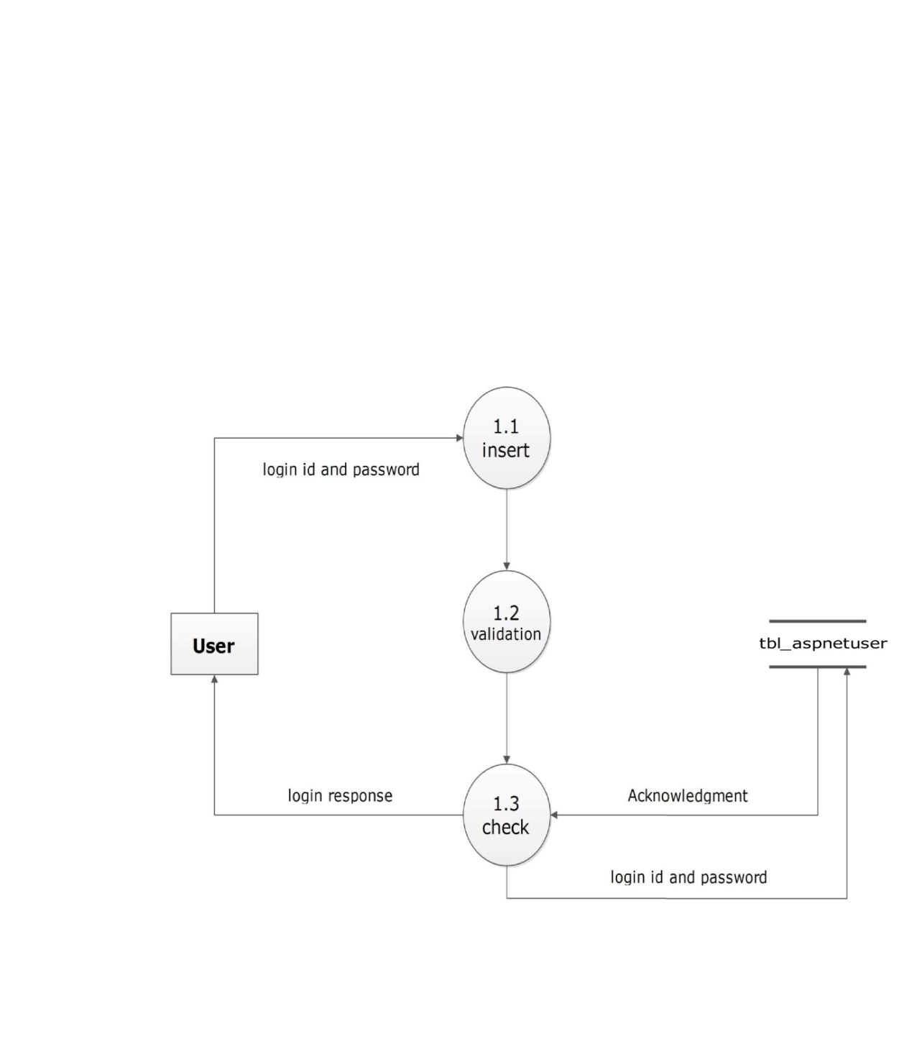

* **Manage User**

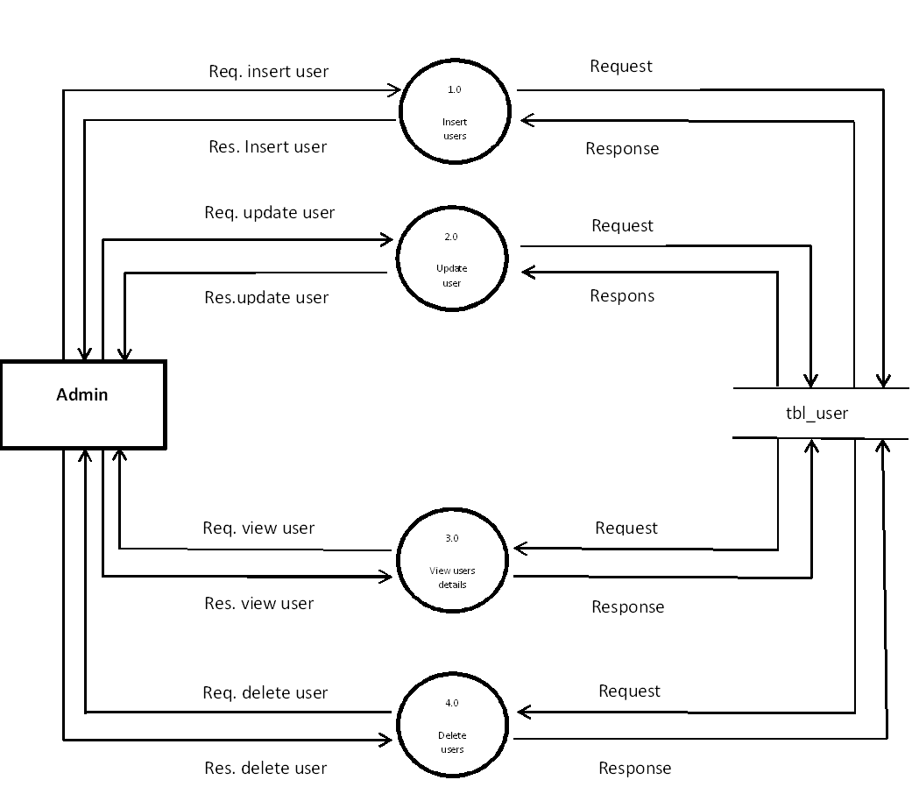

4.0

Delete

Insert

Update

3.0

View User

Insert

Update

2.0

Update

Insert

Update

1.0

Insert

Insert

Update

* **Manage Staff**

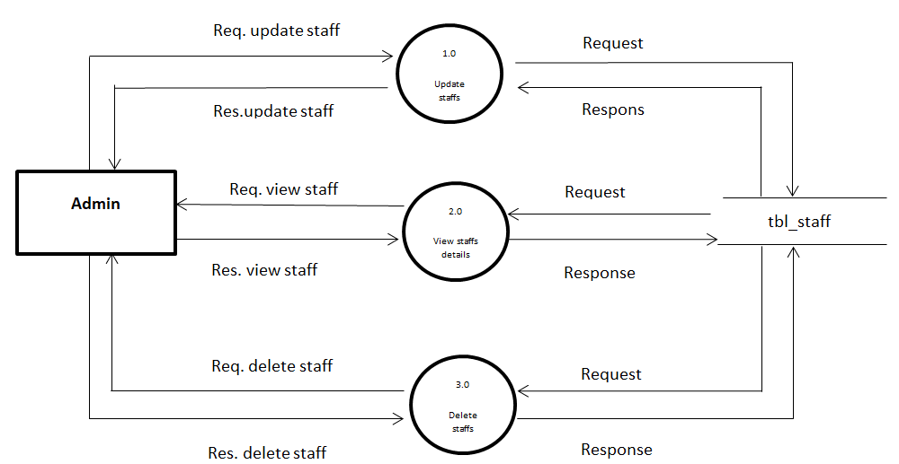

**5.2 Process Specification**

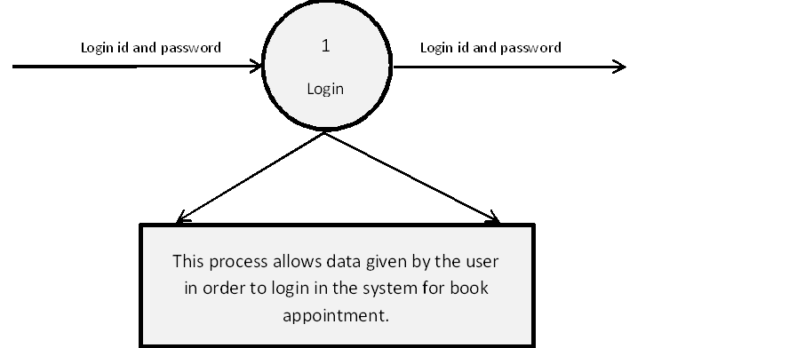

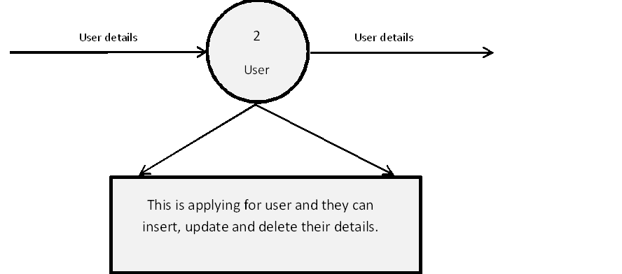

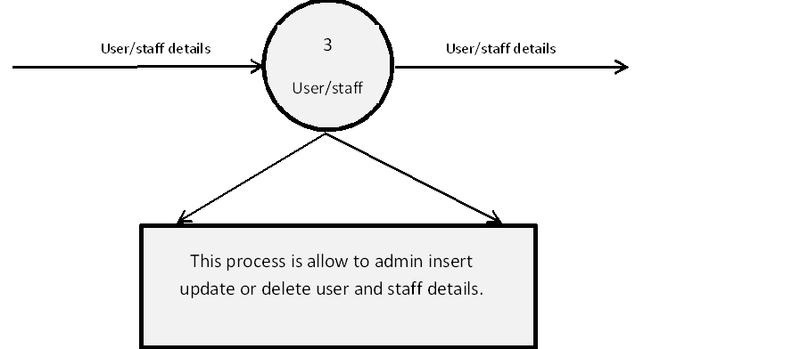

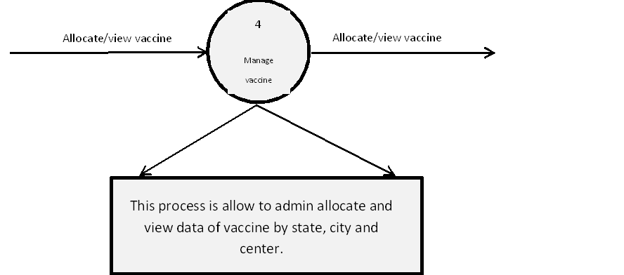

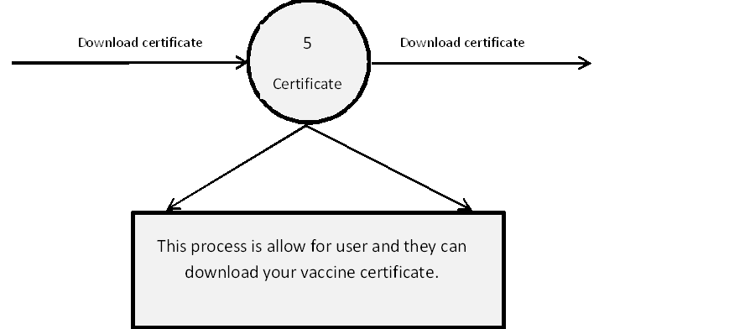

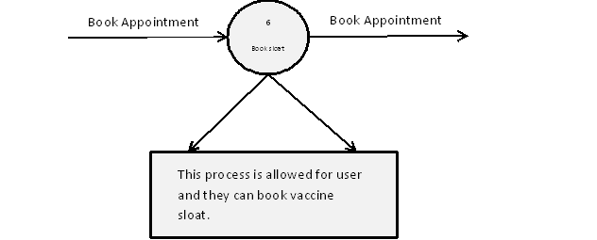

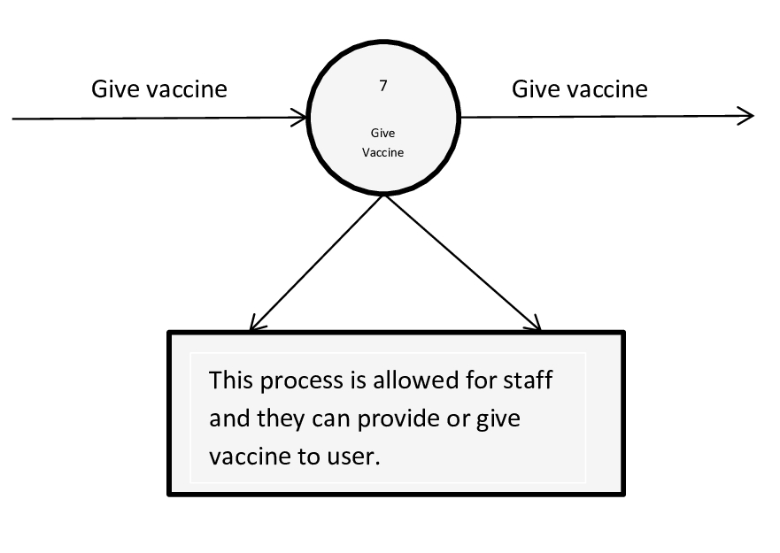

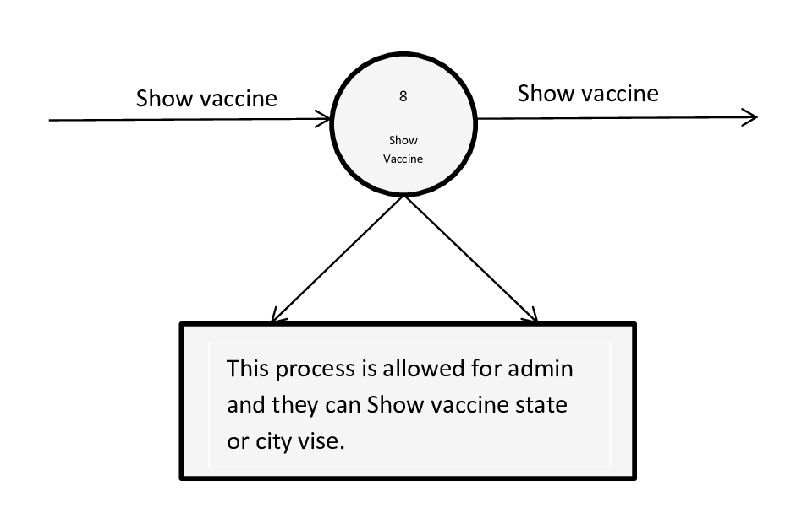

****\

* 1. **Data Dictionary**
* **Vaccine**

|  |  |
| --- | --- |
| **Name** | Vaccine |
|  |  |
| **Alias** | Null |
|  |  |
| **Where used/How used** | Type of vaccine |
|  |  |
| **Content Description** | Id,Name,Disease |
|  |  |
| **Supplementary Information** | To show types of Vaccine |
|  |  |

* **Vaccinated User**

|  |  |
| --- | --- |
| **Name** | VaccinatedUserMaster |
|  |  |
| **Alias** | Null |
|  |  |
| **Where used/How used** | See next dose Date and download Certificate |
|  |  |
| **Content Description** | Id,Userid,Sloatid,Staffid,DoseDate,NextDose,DoseNo |
|  |  |
| **Supplementary Information** | To show Details of Vaccinated Users |
|  |  |

* **User**

|  |  |
| --- | --- |
| **Name** | User |
|  |  |
| **Alias** | Null |
|  |  |
| **Where used/How used** | Store User Registration Data |
|  |  |
| **Content Description** | Id,Userid,FirstName,MiddleName, LastName,Gender,AdharNo,dob,ProfilePic,Age |
|  |  |
| **Supplementary Information** | To show Details of Users |
|  |  |

* **Staff**

|  |  |
| --- | --- |
| **Name** | Staff |
|  |  |
| **Alias** | Null |
|  |  |
| **Where used/How used** | Store staff Registration Data |
|  |  |
| **Content Description** | Id,Userid,FirstName,MiddleName, LastName,Gender,PhNo,dob,ProfilePic,Address,Degree,Specialist |
|  |  |
| **Supplementary Information** | To show Details of Staff |
|  |  |

* **StateMaster**

|  |  |
| --- | --- |
| **Name** | StateMaster |
|  |  |
| **Alias** | Null |
|  |  |
| **Primary Key** | State id |
| **Where used** | State’s Vaccine Data |
|  |  |
| **Content Description** | Id,Name |
|  |  |
| **Supplementary Information** | To show Details of States |
|  |  |

* **TokenMaster**

|  |  |
| --- | --- |
| **Name** | TokenMaster |
|  |  |
| **Alias** | Null |
|  |  |
| **Primary Key** | Token id |
| **Where used** | Reset Password |
|  |  |
| **Content Description** | Id,UserId,Tokens,GenerateTime,ExpireTime |
|  |  |
| **Supplementary Information** | To use of forgot password |
|  |  |

* **SloatMaster**

|  |  |
| --- | --- |
| **Name** | SloatMaster |
|  |  |
| **Alias** | Null |
|  |  |
| **Primary Key** | Sloat id |
| **Where used** | Book Vaccine Appointment |
|  |  |
| **Content Description** | Id,UserId,stateId,cityId,CenterId,vaccineId,Doseno,Appointmentdate,Sloatscount |
|  |  |
| **Supplementary Information** | To Store User Id , Name, Appointment Date, Dose No. in table |
|  |  |

* **AspNetUserRoles**

|  |  |
| --- | --- |
| **Name** | AspNetUserRoles |
|  |  |
| **Alias** | Null |
|  |  |
| **Primary Key** | UserId,RoleId |
| **Where used** | Assign Role |
|  |  |
| **Content Description** | UserId,RoleId |
|  |  |
| **Supplementary Information** | To assign role to Admin, staff,and user. |
|  |  |

* **CityMaster**

|  |  |
| --- | --- |
| **Name** | CityMaster |
|  |  |
| **Alias** | Null |
|  |  |
| **Primary Key** | City id |
| **Foreign Key** | Stateid |
| **Where used** | City’s Vaccine Data |
|  |  |
| **Content Description** | Id,StateId,Name |
|  |  |
| **Supplementary Information** | To show Details of Cities |
|  |  |

* **CenterMaster**

|  |  |
| --- | --- |
| **Name** | CenterMaster |
|  |  |
| **Alias** | Null |
|  |  |
| **Primary Key** | Centerid |
| **Foreign Key** | Cityid |
| **Where used** | Centre’s Vaccine Data |
|  |  |
| **Content Description** | Id,CityId,Name,Location |
|  |  |
| **Supplementary Information** | To show details of Centers |
|  |  |

* **MapVaccineMaster**

|  |  |
| --- | --- |
| **Name** | MapVaccineMaster |
|  |  |
| **Alias** | Null |
|  |  |
| **Primary Key** | Userid |
| **Where used** | Data of available Vaccine in Centre |
|  |  |
| **Content Description** | Id,StateId,CityId,CenterId,vaccineId,StateTotalVaccine, StateAvailableVaccine,CityTotalVaccine, CityAvailableVaccine, CenterTotalVaccine, CenterAvailableVaccine,Date, |
|  |  |
| **Supplementary Information** | To Use Of collect data Vaccination center |
|  |  |

* **AspNetUsers**

|  |  |
| --- | --- |
| **Name** | AspNetUsers |
|  |  |
| **Alias** | Null |
|  |  |
| **Primary Key** | UserId |
| **Where used** | Manage User Data and Access |
|  |  |
| **Content Description** | Id,UserName,NormalizedUserName,Email,NormalizedEmail,EmailConfirmed,PasawordHash,SecurityStamp,ConcurrencyStamp,phoneNumber, phoneNumberConfirmed,TwoFactorEnabled,LockoutEnd,LockoutEnabled,AccessFailedCount |
|  |  |
| **Supplementary Information** | For user Information |
|  |  |

* **AspNetRoles**

|  |  |
| --- | --- |
| **Name** | AspNetRoles |
|  |  |
| **Alias** | Null |
|  |  |
| **Primary Key** | RoleId |
| **Where used** | For specific Role |
|  |  |
| **Content Description** | Id,Name |
|  |  |
| **Supplementary Information** | To assign user specify roles |
|  |  |



**5.4 Entity-Relationship Diagram**

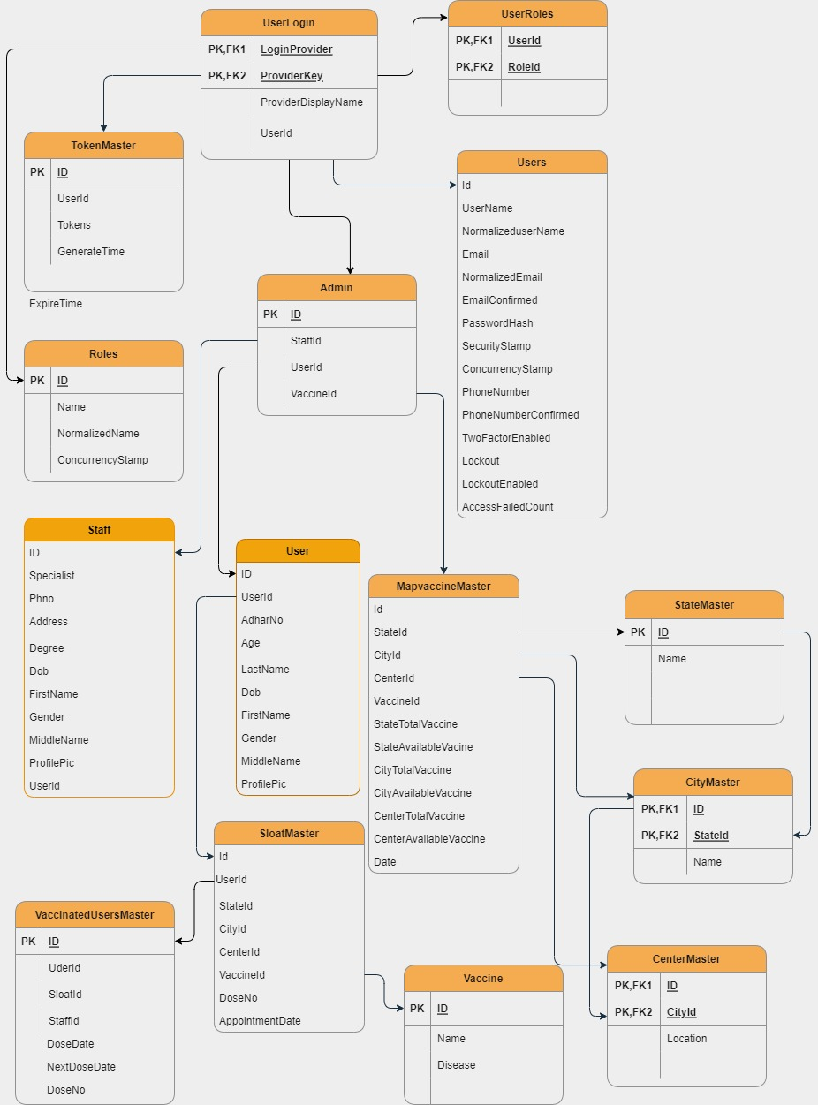

**6**

Chapter

**System Design**

6.1 Database Design

6.2 Directory Structure

6.3 Input Design

6.4 Output Design



**6.1 Database Design**

**Table : Vaccine**

|  |  |  |  |  |
| --- | --- | --- | --- | --- |
| **Sr No.** | **Field Name** | **Data Type** | **Constraints** | **Description** |
|  |  |  |  |  |
| 1 | ID | Int | PK | Unique Vaccine ID. |
|  |  |  |  |  |
| 2 | Name | Nvarchar[MAX] | Null | Vaccine of User. |
|  |  |  |  |  |
| 3 | Disease | Nvarchar[MAX] | Null | Disease of vaccine |
|  |  |  |  |  |

**Table : Vaccinated User**

|  |  |  |  |  |
| --- | --- | --- | --- | --- |
| **Sr No.** | **Field Name** | **Data Type** | **Constraints** | **Description** |
|  |  |  |  |  |
| 1 | ID | Int | PK | Unique Vaccine ID. |
|  |  |  |  |  |
| 2 | UserID | Nvarchar[450] | Null | UserID |
|  |  |  |  |  |
| 3 | SloatID | Nvarchar[MAX] | Null | SloatID |
|  |  |  |  |  |
| 4 | DoseDate | Datetime2(7) | Null | Date of user get vaccine |
| 5 | StaffID | Nvarchar[MAX] | Null | SloatID |
| 6 | NextDoseDate | Datetime2(7) | Null | Date of Next vaccine dose |
| 7 | DoseNo | Int | Not null | Dose no which user get |

**Table : TokenMaster**

|  |  |  |  |  |
| --- | --- | --- | --- | --- |
| **Sr No.** | **Field Name** | **Data Type** | **Constraints** | **Description** |
|  |  |  |  |  |
| 1 | ID | Int | PK | Unique ID |
|  |  |  |  |  |
| 2 | UserID | Nvarchar[450] | Null | UserID |
|  |  |  |  |  |
| 3 | Tokens | Nvarchar[MAX] | Null | Token for reset password |
|  |  |  |  |  |
| 4 | Generatetime | Datetime2(7) | Not Null | Token generate time |
| 5 | Expiretime | Datetime2(7) | Not Null | Token expire time |

**Table : MapVaccine**

|  |  |  |  |  |
| --- | --- | --- | --- | --- |
| **Sr No.** | **Field Name** | **Data Type** | **Constraints** | **Description** |
|  |  |  |  |  |
| 1 | ID | Int | PK | Unique Admin ID. |
|  |  |  |  |  |
| 2 | StateId | Int | Not Null | State |
|  |  |  |  |  |
| 3 | CityId | Int | Not Null | City |
|  |  |  |  |  |
| 4 | CenterId | Int | Not Null | Centre |
| 5 | VaccineId | Int | Not Null | Id of Vaccine |
| 6 | StateTotalVaccine | Int | Not Null | State Vice total Vaccine |
| 7 | StateAvailableVaccine | Int | Not null | State Vice Available vaccine |
| 8 | CityTotalVaccine | Int | Not Null | City Vice Total vaccine |
|  |  |  |  |  |
| 9 | CityAvailabeVaccine | Int | Not Null | City Vice Available vaccine |
|  |  |  |  |  |
|  |  |  |  |  |
| 10 | CenterTotalVaccine | Int | Not Null | Center Vice Total vaccine |
| 11 | CenterAvailabeVaccine | Int | Not Null | Center Vice Available vaccine |
| 12 | Date | DateTime2(7) | Not Null | Date |

**Table : CenterMaster**

|  |  |  |  |  |
| --- | --- | --- | --- | --- |
| **Sr No.** | **Field Name** | **Data Type** | **Constraints** | **Description** |
|  |  |  |  |  |
| 1 | ID | Int | PK | Unique Center ID |
|  |  |  |  |  |
| 2 | CityId | Int | Not Null | Id of city |
|  |  |  |  |  |
| 3 | Name | Nvarchar[MAX] | Null | Name of center |
|  |  |  |  |  |
| 4 | Location | Nvarchar[MAX] | Null | Location of center |
|  |  |  |  |  |

**Table : User**

|  |  |  |  |  |
| --- | --- | --- | --- | --- |
| **Sr No.** | **Field Name** | **Data Type** | **Constraints** | **Description** |
|  |  |  |  |  |
| 1 | ID | Int | PK | Unique ID |
|  |  |  |  |  |
| 2 | UserId | Nvarchar[450] | Null | Unique user ID |
|  |  |  |  |  |
| 3 | FirstName | Nvarchar[MAX] | Not Null | First Name |
|  |  |  |  |  |
| 4 | LastName | Nvarchar[MAX] | Not Null | Last Name |
| 5 | MiddleName | Nvarchar[MAX] | Not Null | Middle Name |
| 6 | Dob | Datetime2(7) | Not Null | Date of Birth |
| 7 | AdharNo | Nvarchar[MAX] | Not null | Adhar number |
| 8 | Gender | Nvarchar[MAX] | Not Null | Gender |
|  |  |  |  |  |
| 9 | Age | Int | Not Null | Age |
|  |  |  |  |  |
| 10 | ProfilePic | Nvarchar[MAX] | Null | Picture of user |
|  |  |  |  |  |

**Table : statemaster**

|  |  |  |  |  |
| --- | --- | --- | --- | --- |
| **Sr No.** | **Field Name** | **Data Type** | **Constraints** | **Description** |
|  |  |  |  |  |
| 1 | ID | Int | PK | Unique state ID |
|  |  |  |  |  |
| 2 | Name | Nvarchar[MAX] | Null | Name of State |
|  |  |  |  |  |

**Table : CityMaster**

|  |  |  |  |  |
| --- | --- | --- | --- | --- |
| **Sr No.** | **Field Name** | **Data Type** | **Constraints** | **Description** |
|  |  |  |  |  |
| 1 | ID | Int | PK | Unique City ID. |
|  |  |  |  |  |
| 2 | StateId | Int | Not Null | Id of state. |
|  |  |  |  |  |
| 3 | Name | Nvarchar[MAX] | Null | Name of city |
|  |  |  |  |  |

**Table : Staff**

|  |  |  |  |  |
| --- | --- | --- | --- | --- |
| **Sr No.** | **Field Name** | **Data Type** | **Constraints** | **Description** |
|  |  |  |  |  |
| 1 | ID | Int | PK | Unique ID. |
|  |  |  |  |  |
| 2 | Specialist | Nvarchar[MAX] | Not Null | Special |
|  |  |  |  |  |
| 3 | Phno | Nvarchar[MAX] | Not Null | Phone number |
|  |  |  |  |  |
| 4 | Address | Nvarchar[MAX] | Not Null | Address |
| 5 | Degree | Nvarchar[MAX] | Not Null | Degree of Staff |
| 6 | Dob | Datetime2(7) | Not Null | Date of Birth |
| 7 | FirstName | Nvarchar[MAX] | Not null | First Name |
| 8 | LastName | Nvarchar[MAX] | Not Null | Last Name |
|  |  |  |  |  |
| 9 | MiddleName | Nvarchar[MAX] | Not Null | Middle Name |
|  |  |  |  |  |
| 10 | ProfilePic | Nvarchar[MAX] | Null | Picture of staff |
|  |  |  |  |  |
| 11 | User ID | Nvarchar[450] | Null | Id of user |

**Table :AspNetUser**

|  |  |  |  |  |
| --- | --- | --- | --- | --- |
| **Sr No.** | **Field Name** | **Data Type** | **Constraints** | **Description** |
|  |  |  |  |  |
| 1 | ID | Int | PK | Unique ID. |
|  |  |  |  |  |
| 2 | UserName | Nvarchar[450] | Null | User name |
|  |  |  |  |  |
| 3 | NormalizedUserName | Nvarchar[256] | Null | User Name valid |
|  |  |  |  |  |
| 4 | Email | Nvarchar[256] | Null | Email |
| 5 | NormalizedEmail | Nvarchar[256] | Null | Email Valid |
| 6 | EmailConfirmed | Bit | Not Null | Email Confirm |
| 7 | PasswordHash | Nvarchar[MAX] | Null | First Name |
| 8 | SecurityStamp | Nvarchar[MAX] | Null | Security |
|  |  |  |  |  |
| 9 | ConcurrencyStamp | Nvarchar[MAX] | Null | Concurrency |
|  |  |  |  |  |
| 10 | PhoneNumber | Nvarchar[MAX] | Null | Phone number |
|  |  |  |  |  |
| 11 | PhoneNumberConfirmed | Bit | Not Null | Phone no. confirm |
| 12 | TwoFactorEnabled | Bit | Not Null | Two Factor |
| 13 | Lockout | DateTimeoffset(7) | Null | Logout |
| 14 | LockoutEnabled | Bit | Not Null | Logout Access |
| 15 | AccessFailedCount | Bit | Not null | Access Fsiled |

**Table : AspnetUserRole**

|  |  |  |  |  |
| --- | --- | --- | --- | --- |
| **Sr No.** | **Field Name** | **Data Type** | **Constraints** | **Description** |
|  |  |  |  |  |
| 1 | UserId | Nvarchar[450] | PK | Unique user ID |
|  |  |  |  |  |
| 2 | RoleId | Nvarchar[450] | PK | Unique role ID |
|  |  |  |  |  |

**Table : SloatMaster**

|  |  |  |  |  |
| --- | --- | --- | --- | --- |
| **Sr No.** | **Field Name** | **Data Type** | **Constraints** | **Description** |
|  |  |  |  |  |
| 1 | ID | Int | PK | Unique ID |
|  |  |  |  |  |
| 2 | UserId | Nvarchar[450] | Null | Unique user ID |
|  |  |  |  |  |
| 3 | StateId | Int | Not Null | StateId |
|  |  |  |  |  |
| 4 | CityId | Int | Not Null | CityId |
| 5 | CenterId | Int | Not Null | CenterId |
| 6 | VaccineId | Int | Not Null | Id of vaccine |
| 7 | DoseNo | Int | Not null | Dose No |
| 8 | AppointmentDate | Datetime2(7) | Not Null | Date of appointment |
| 9 | SloatCount | Bit | Not Null | Count sloats |

**Table : AspnetRoles**

|  |  |  |  |  |
| --- | --- | --- | --- | --- |
| **Sr No.** | **Field Name** | **Data Type** | **Constraints** | **Description** |
|  |  |  |  |  |
| 1 | ID | Nvarchar[256] | PK | Unique ID. |
|  |  |  |  |  |
| 2 | Name | Nvarchar[256] | Null | User name |
|  |  |  |  |  |
| 3 | NormalizedName | Nvarchar[256] | Null | User Name valid |
|  |  |  |  |  |
| 4 | ConcurrencyStamp | Nvarchar[MAX] | Null | Concurrency |

**6.2 Input Design**

* **Customer Side**

**Sign In**

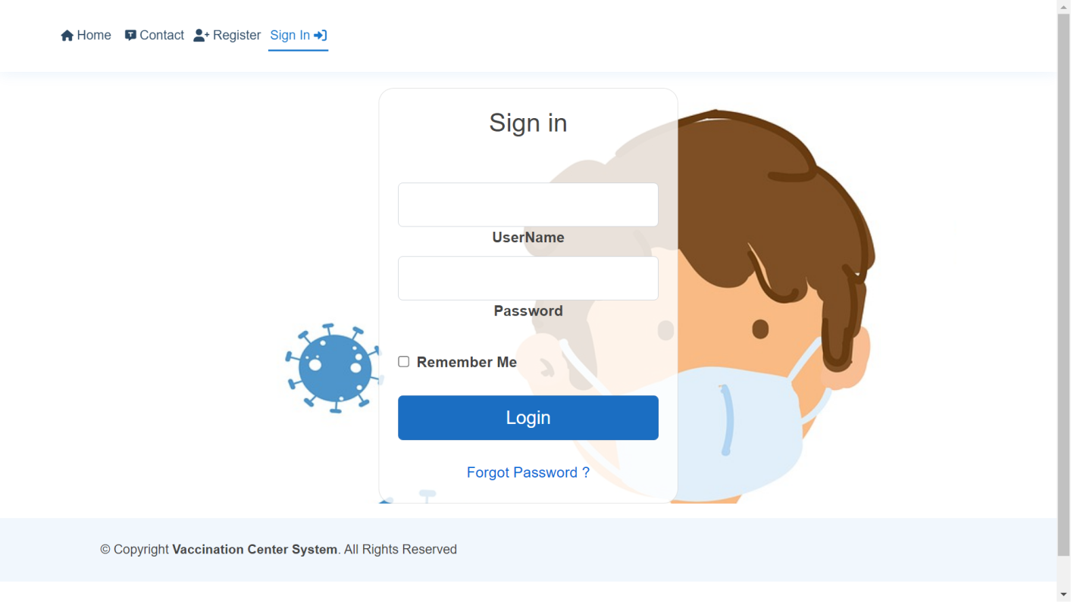

**Forgot Password**

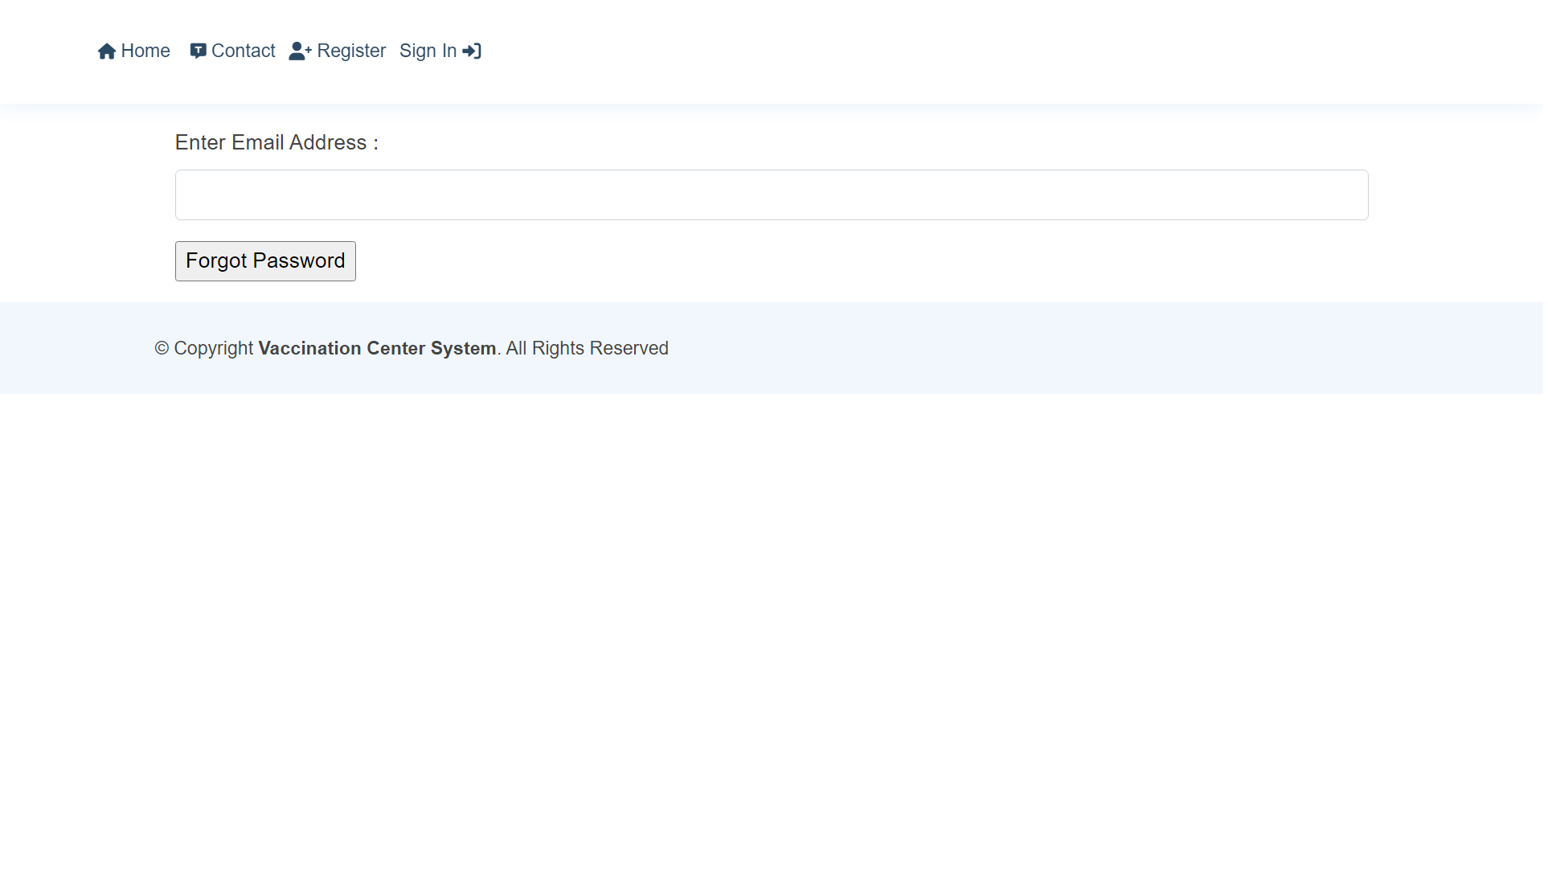

**User Registration**

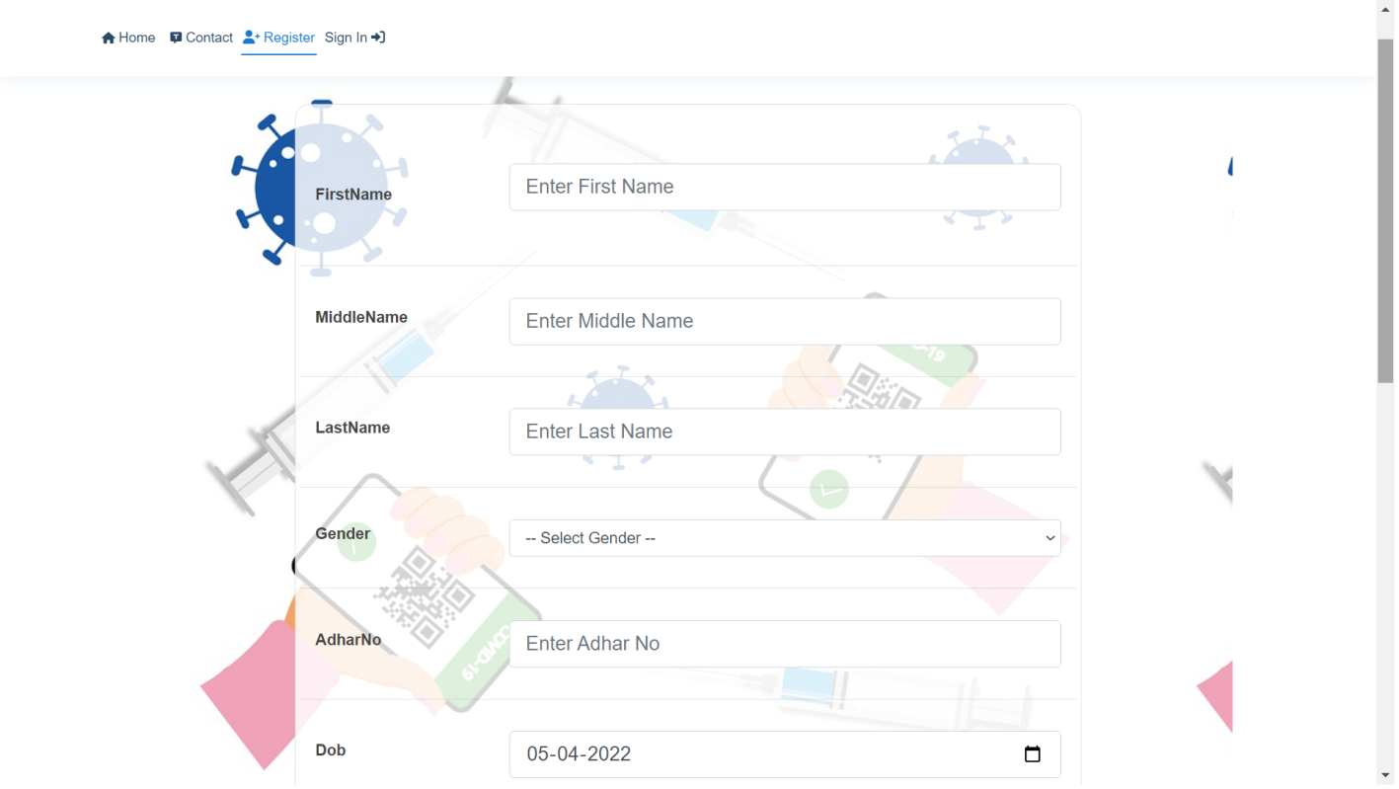

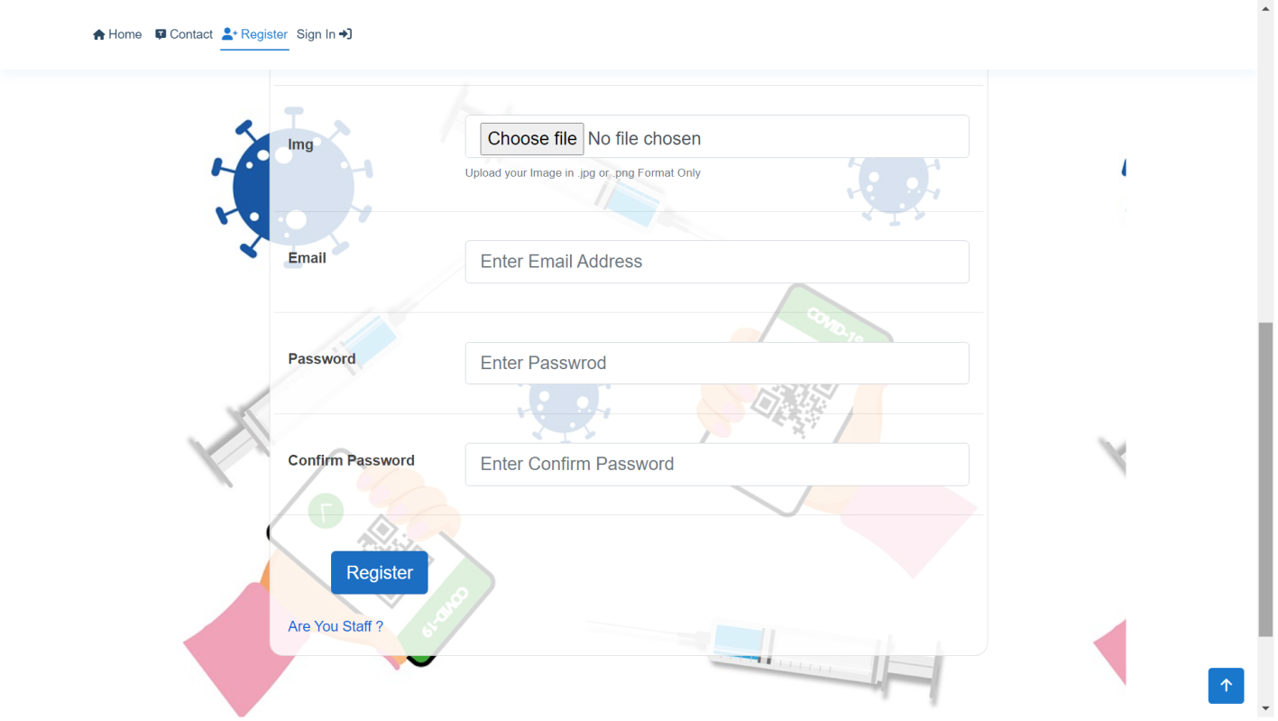

**Update Profile**

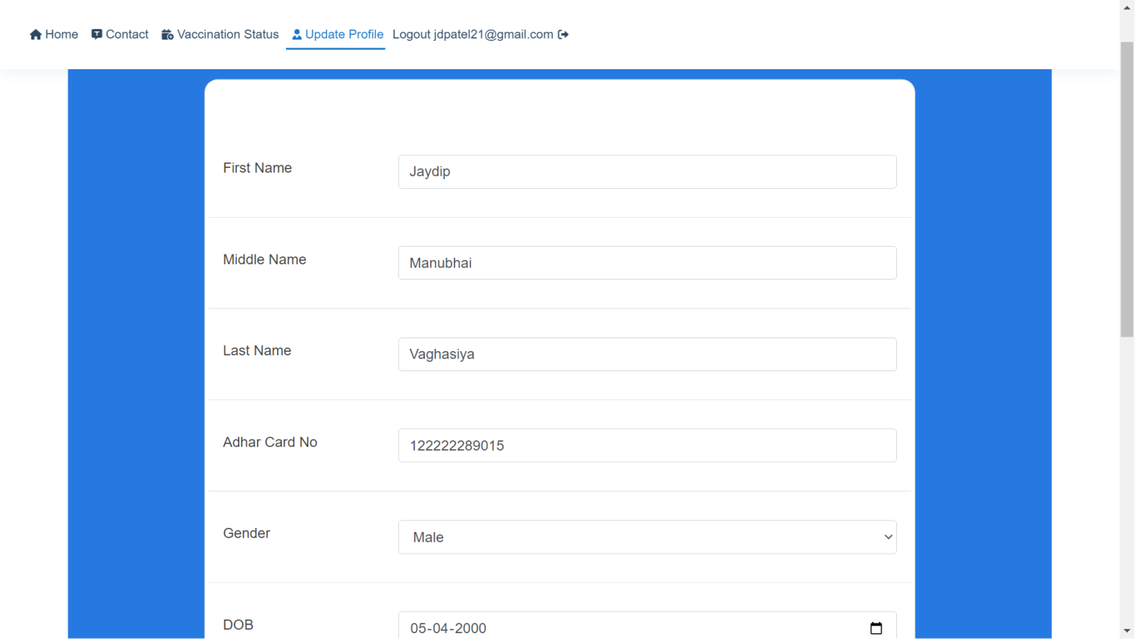

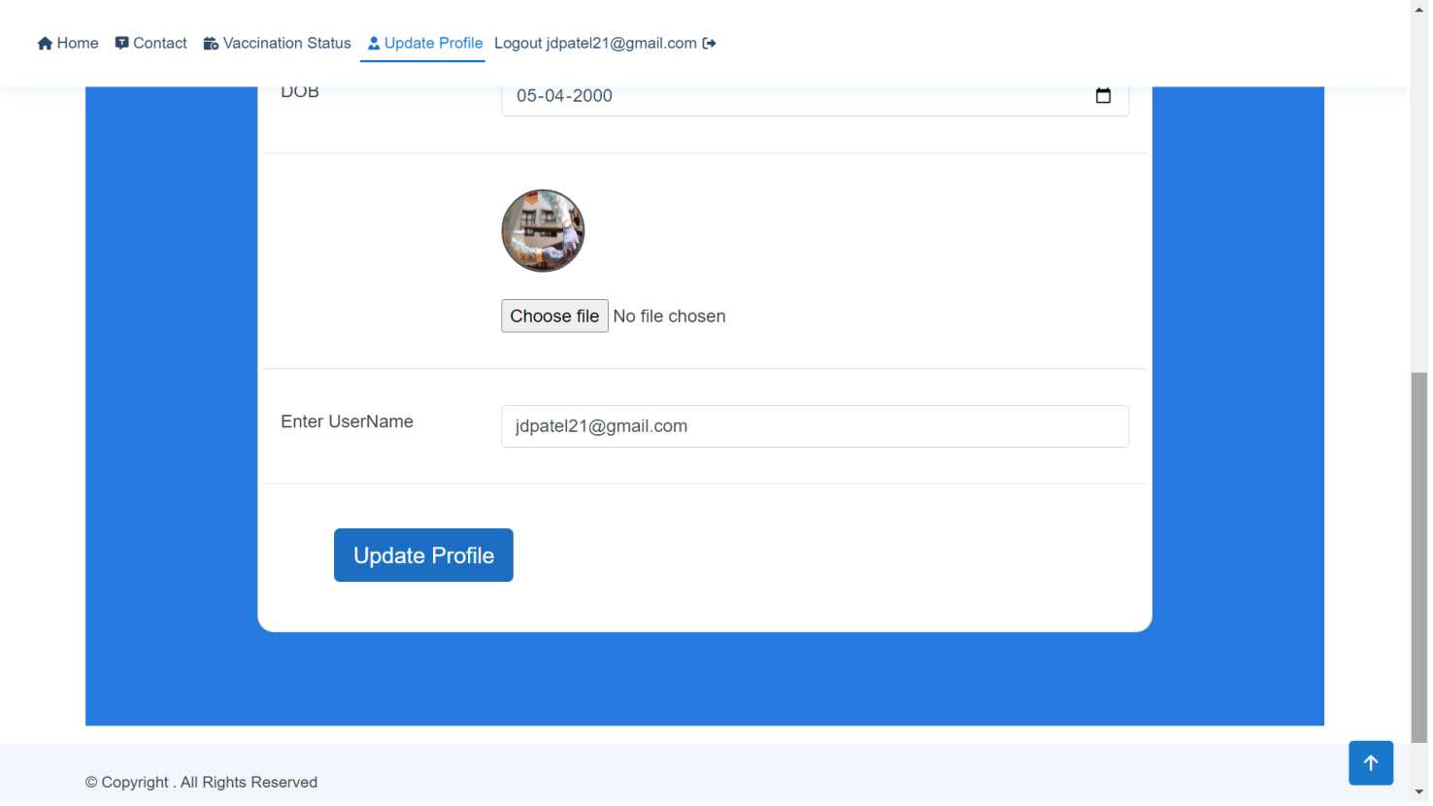

**Home**

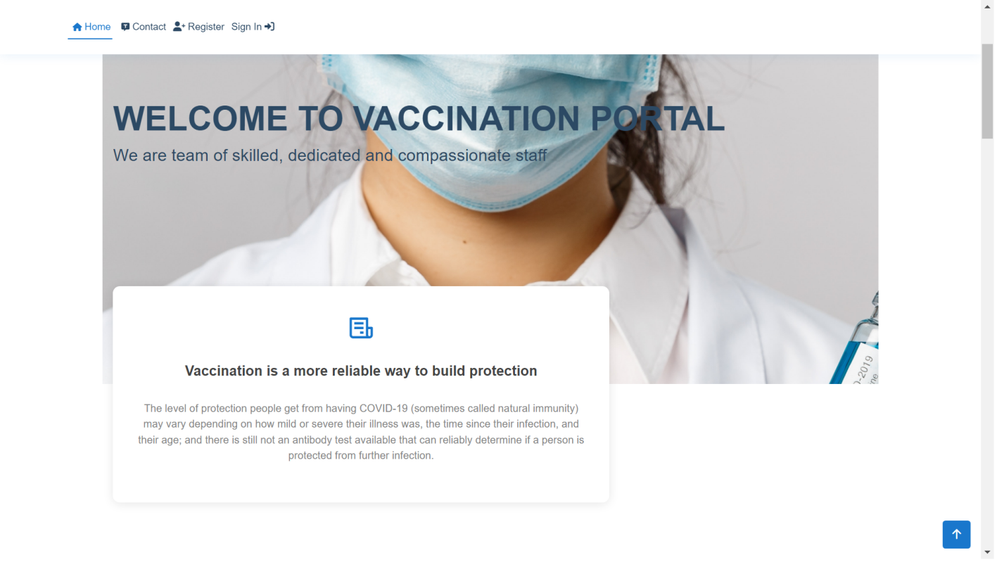

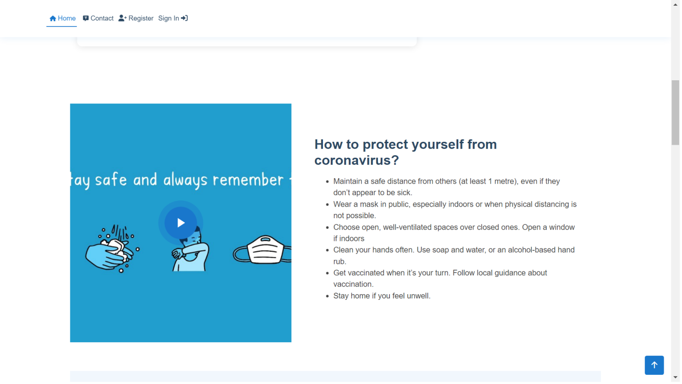

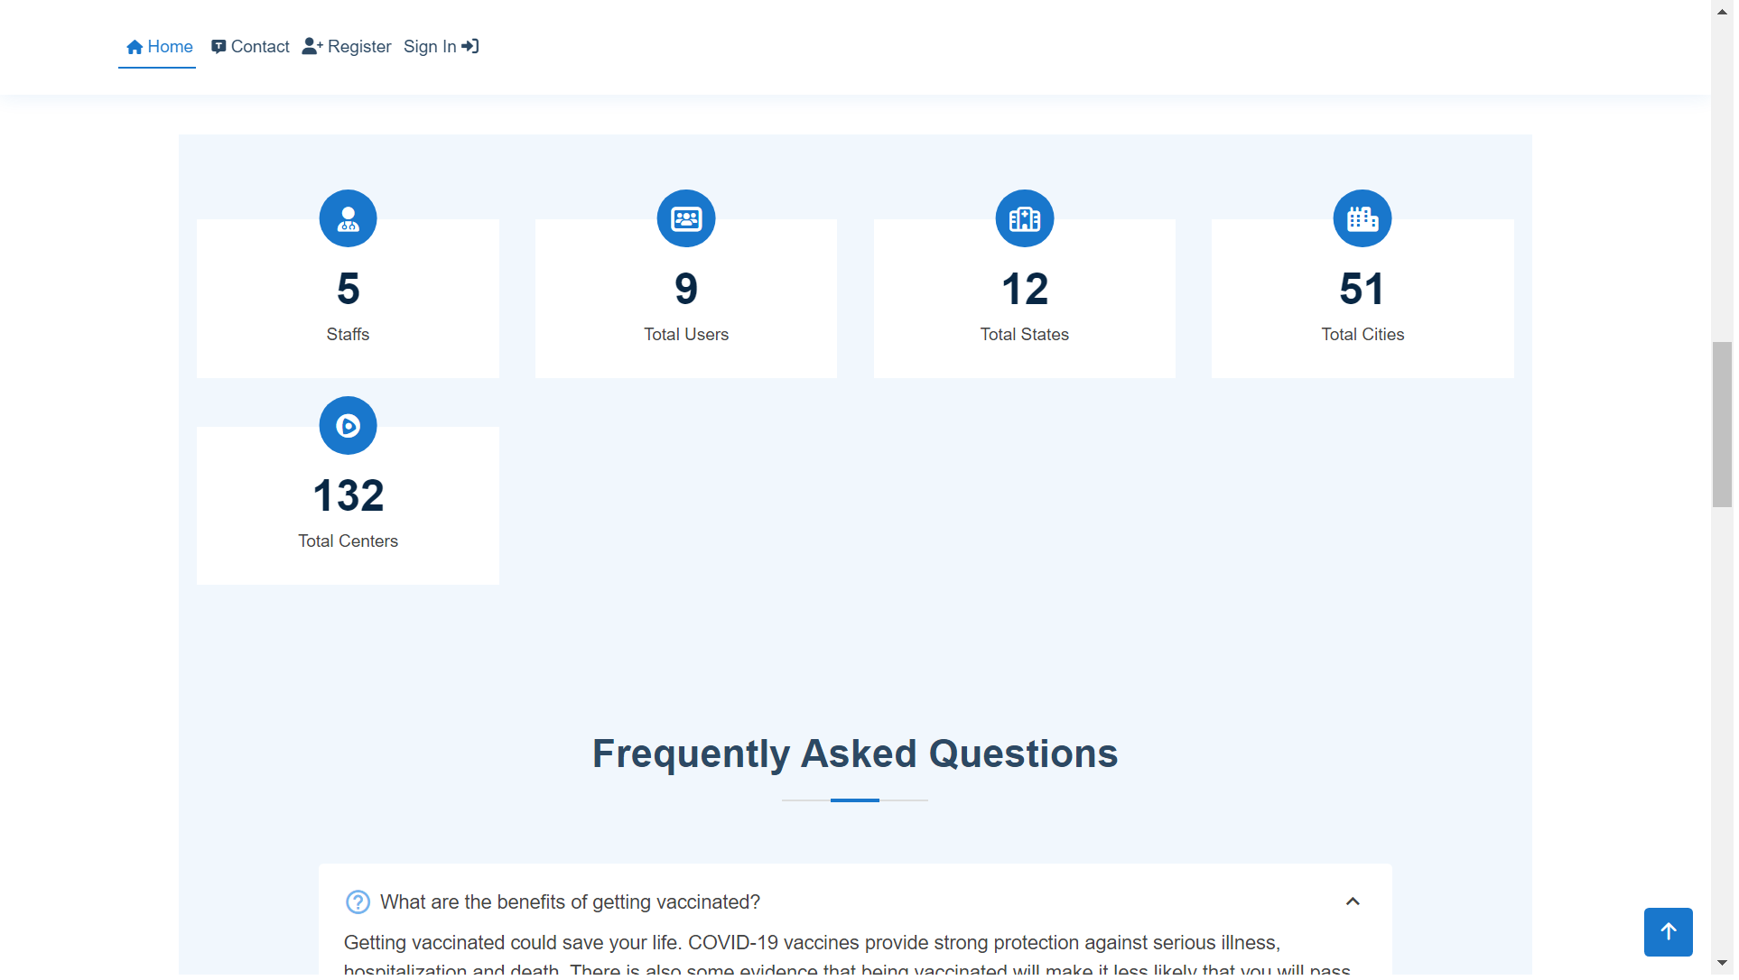

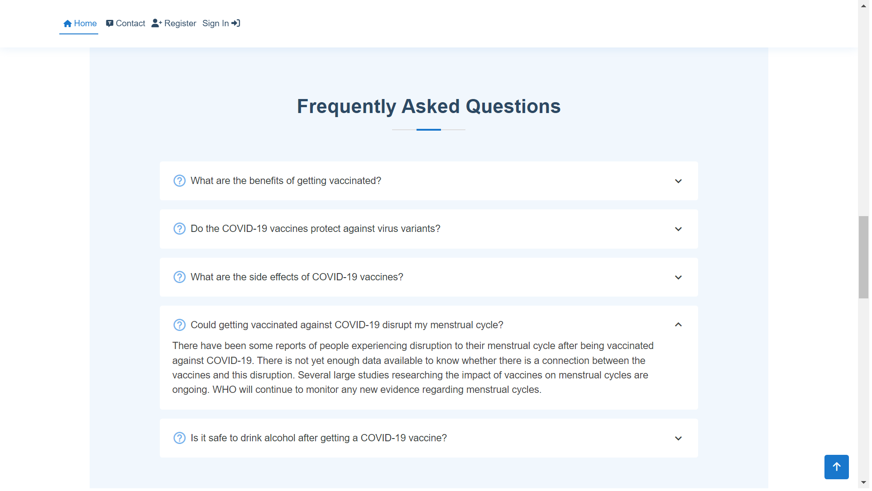

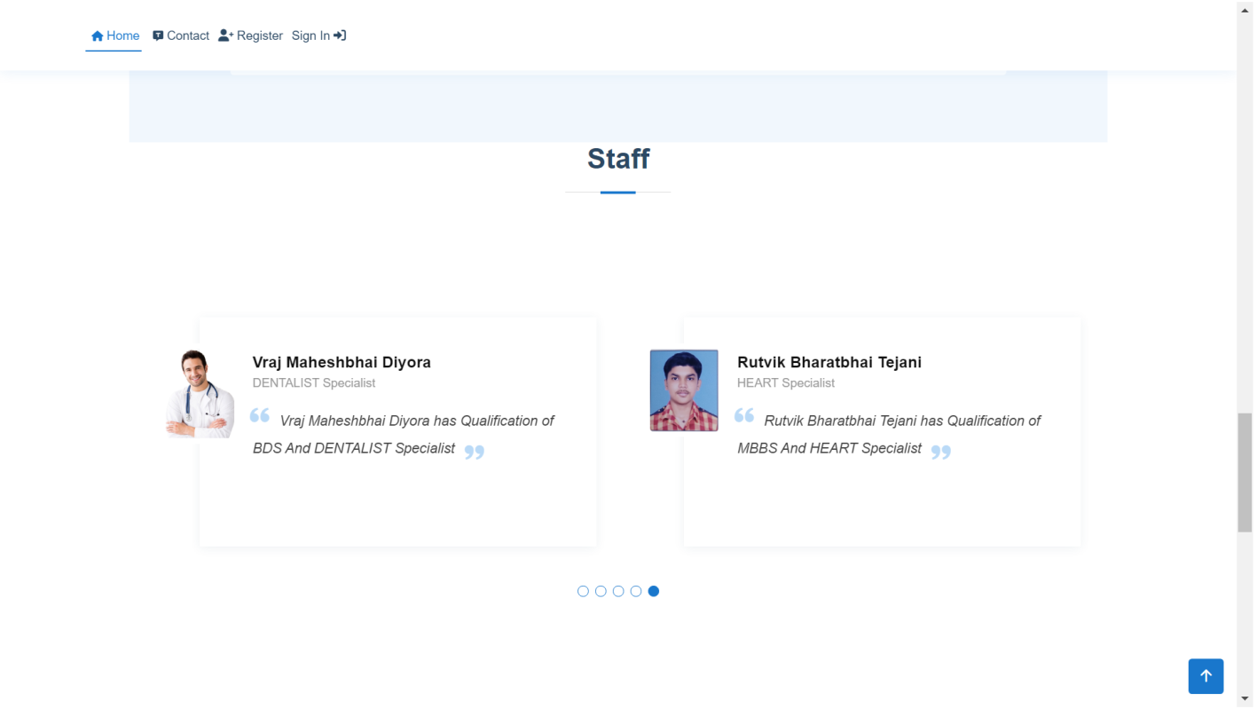

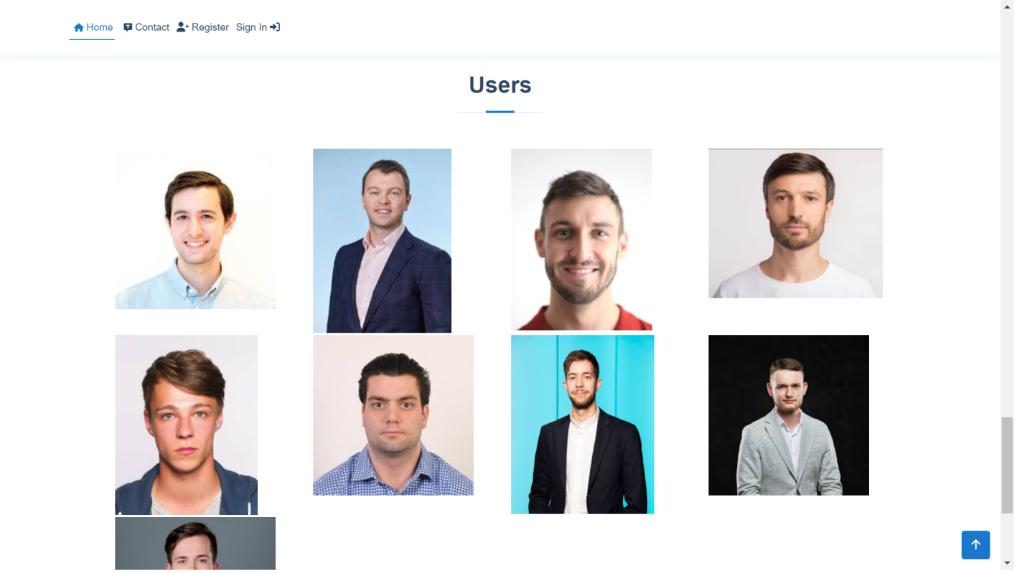

**Appointment**

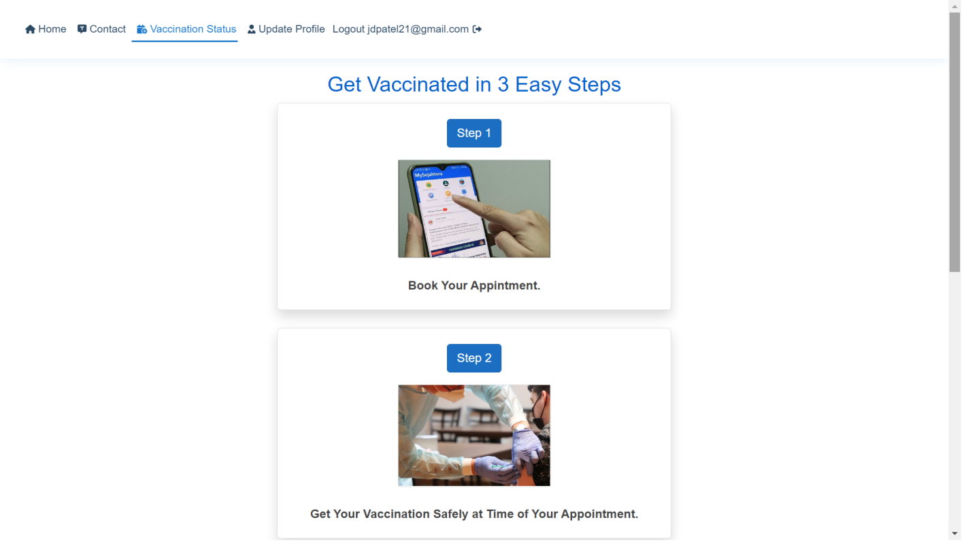

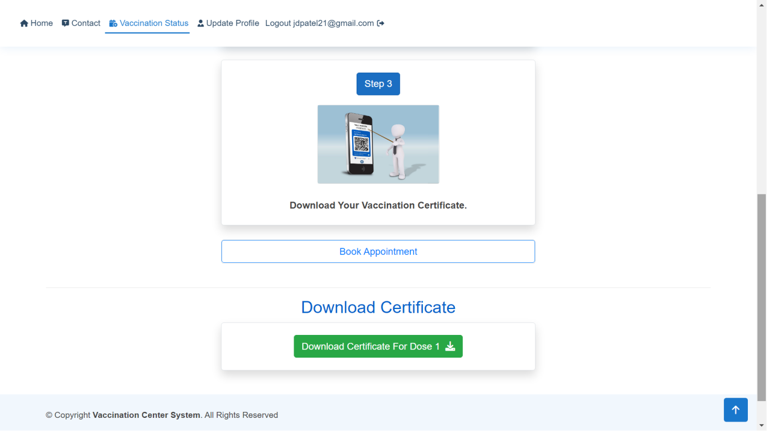

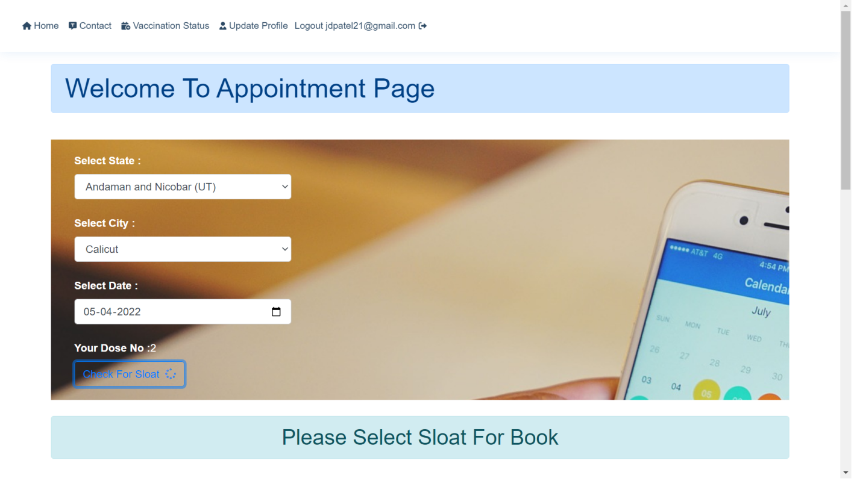

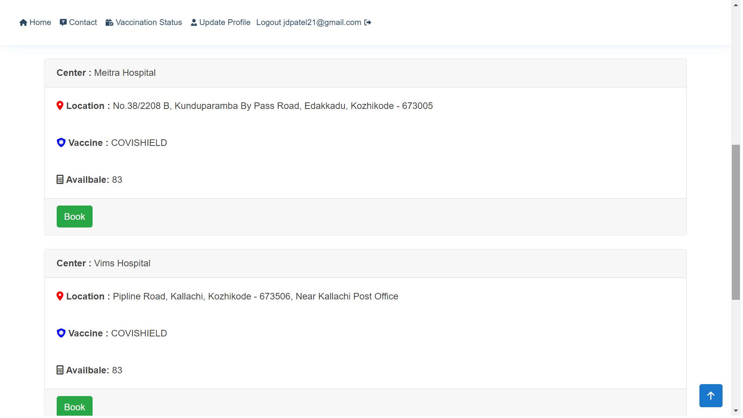

**Contact**

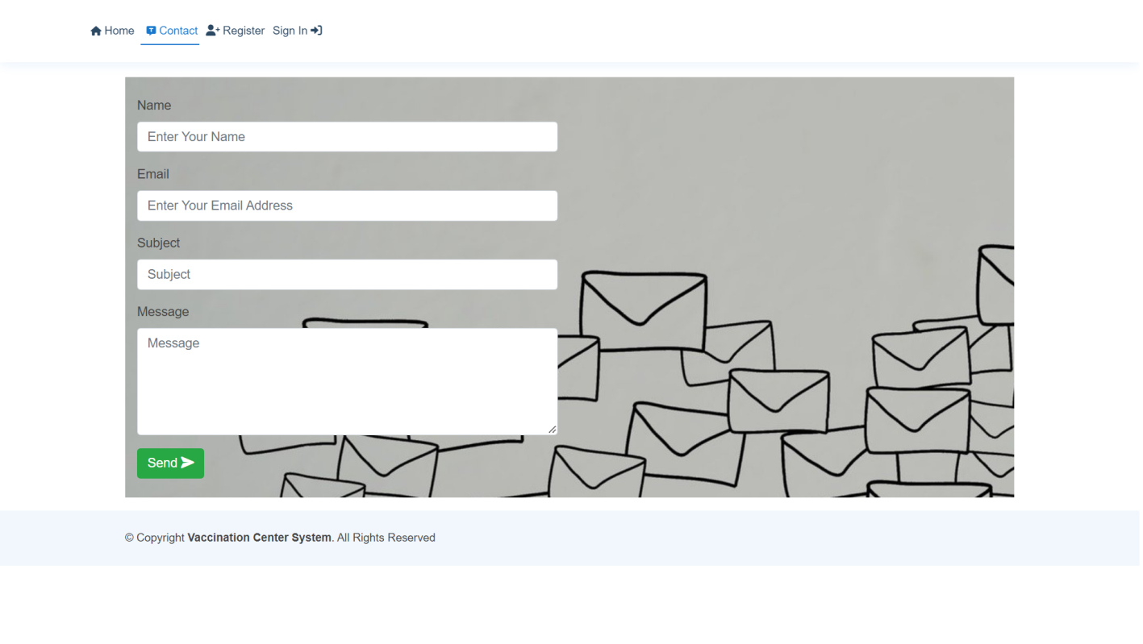

* **Staff Side**

**Registration**

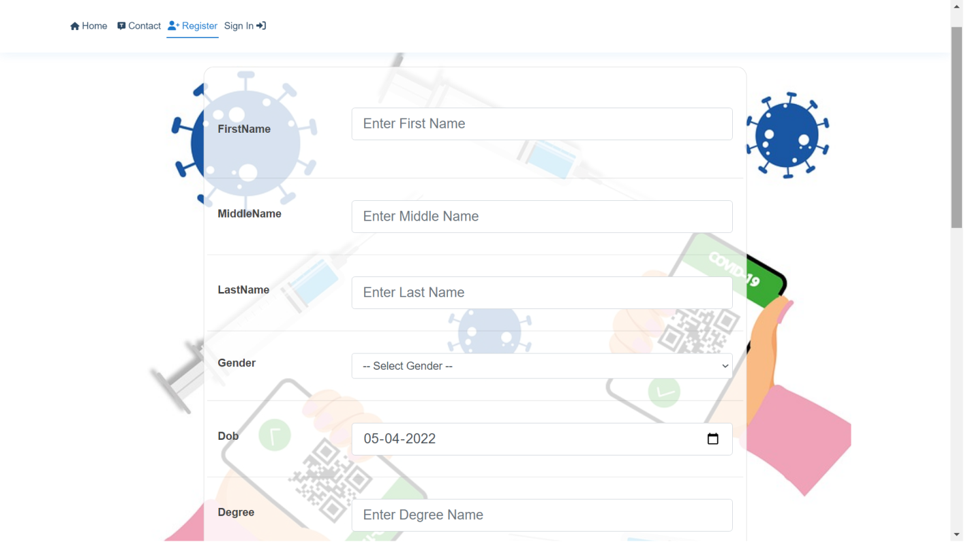

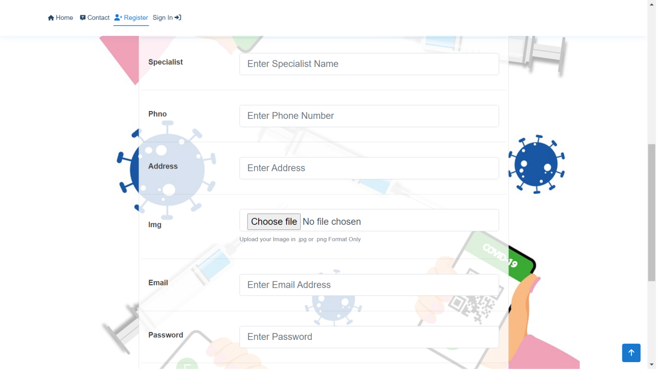

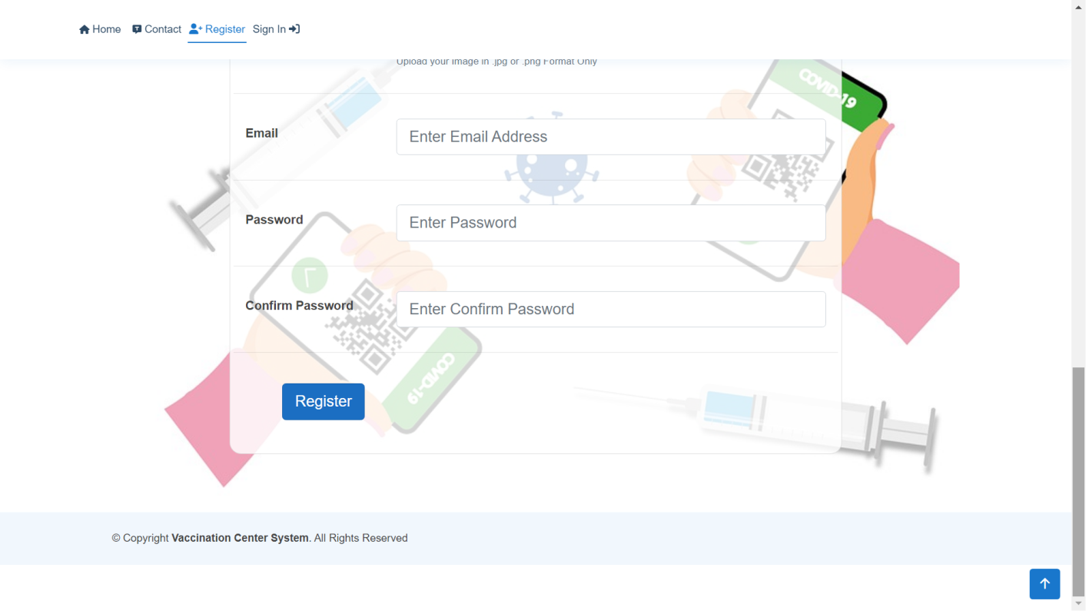

**Give Vaccine**

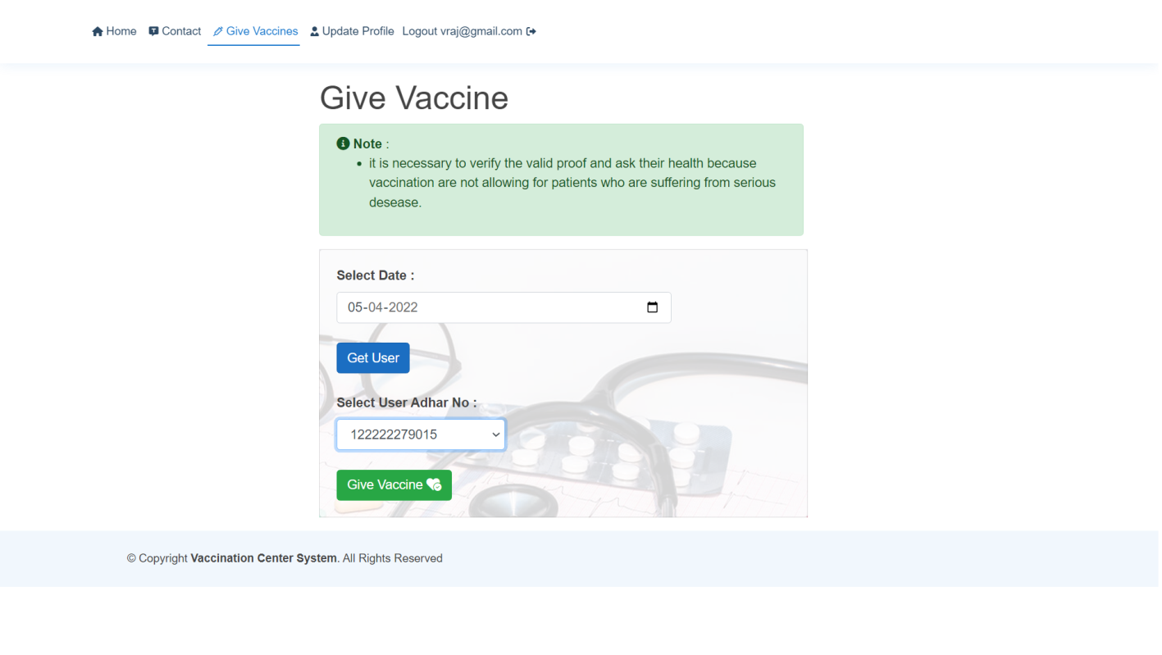

**6.3 Output Design**



**Download Certificate**

**(User)**

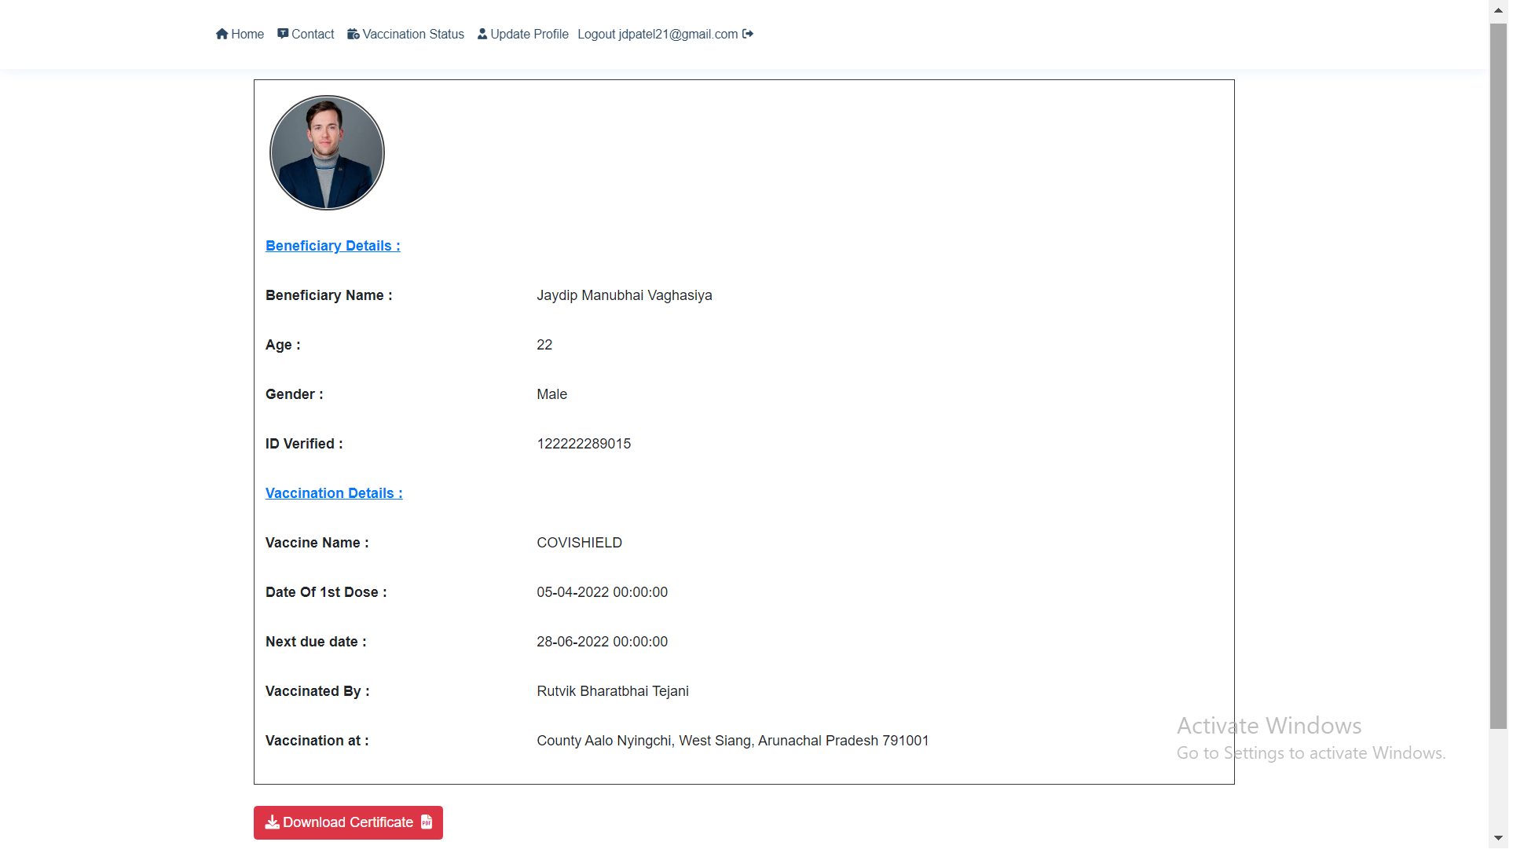

* **Admin**

**Allocate Vaccine**

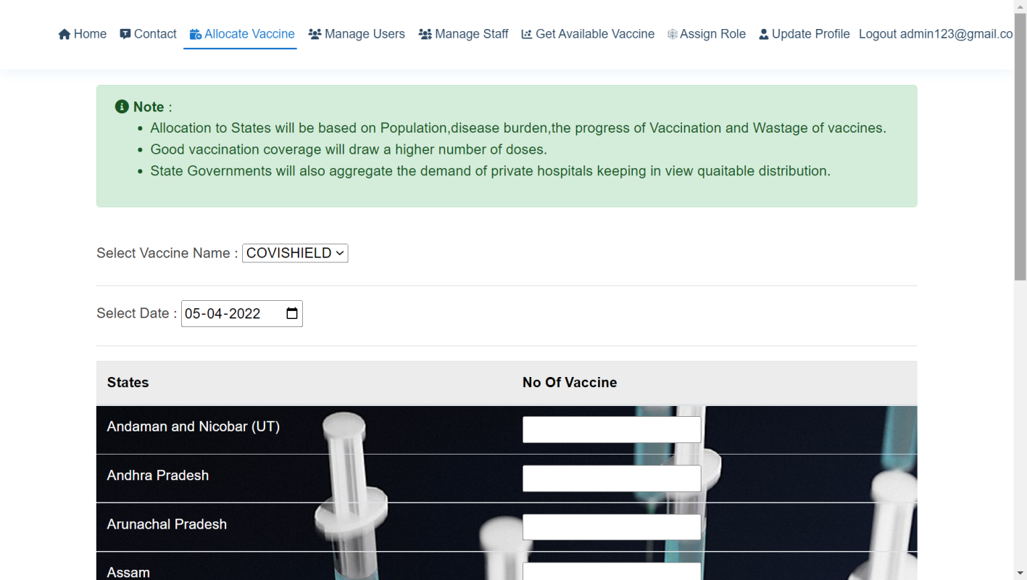

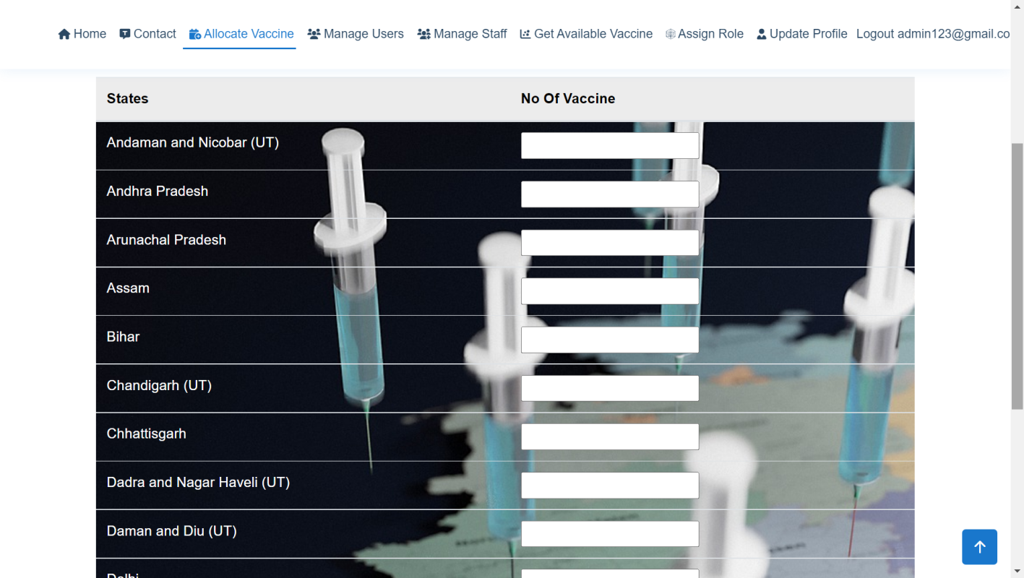

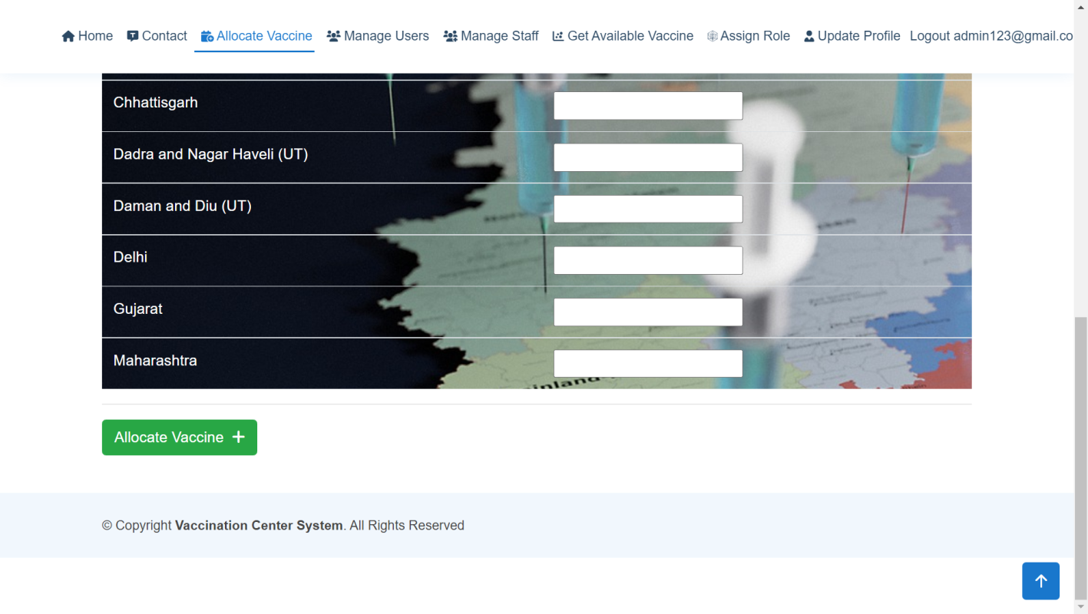

**Get Available Vaccine**

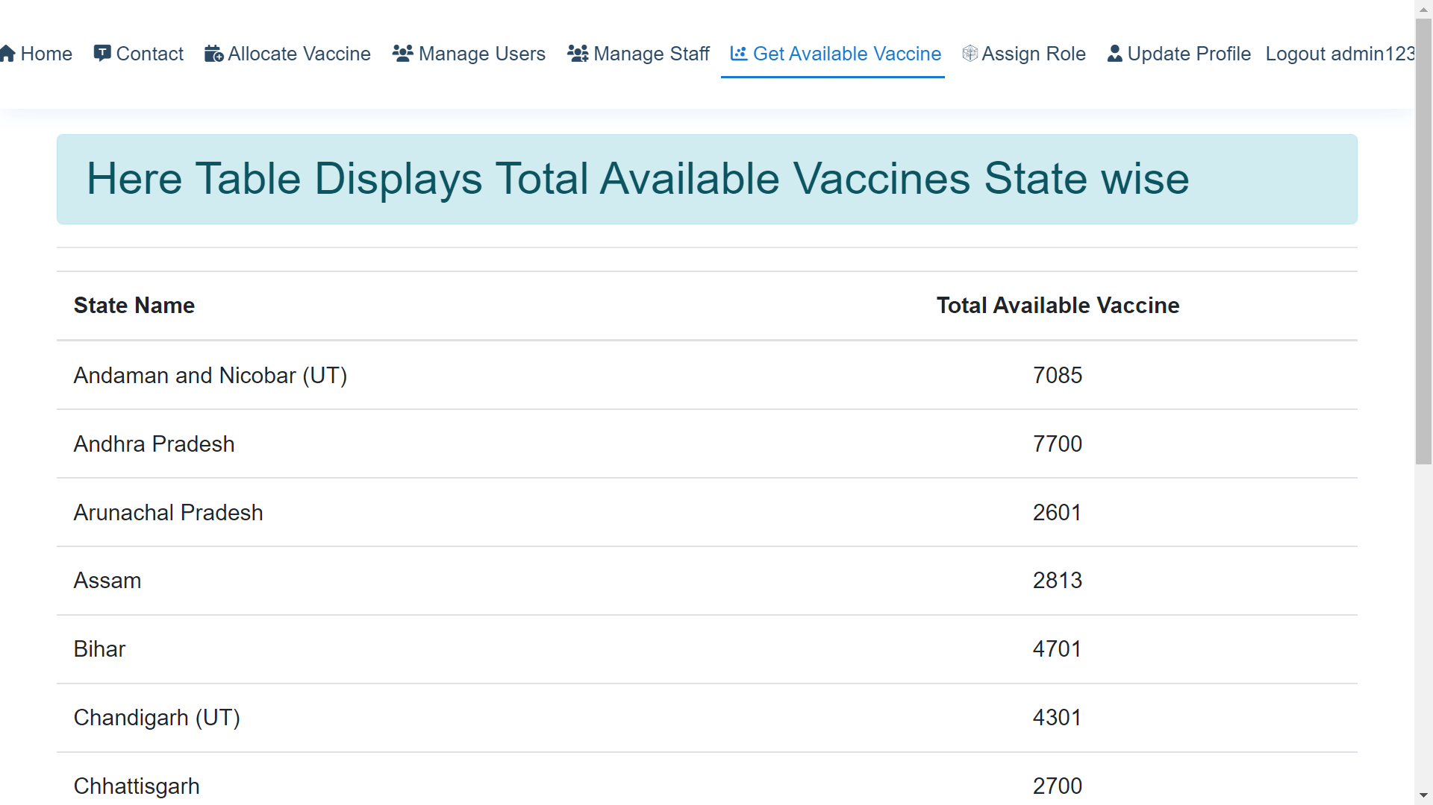

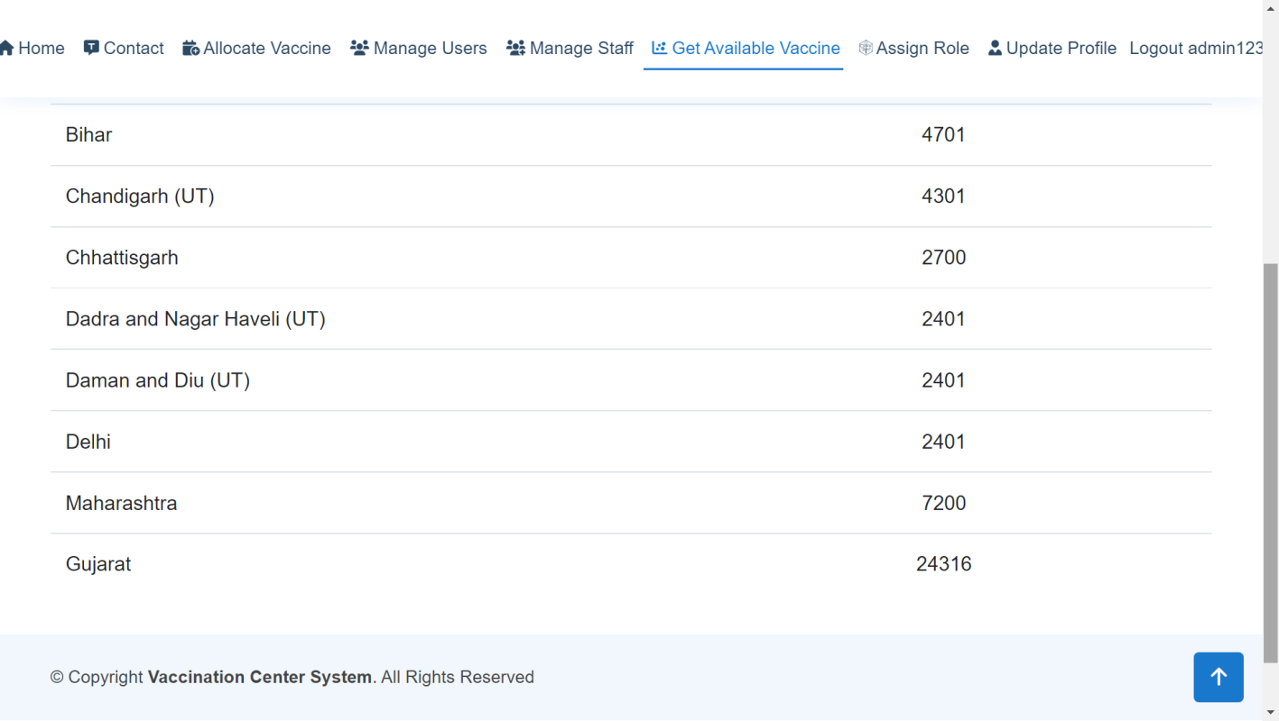

**Manage Role**

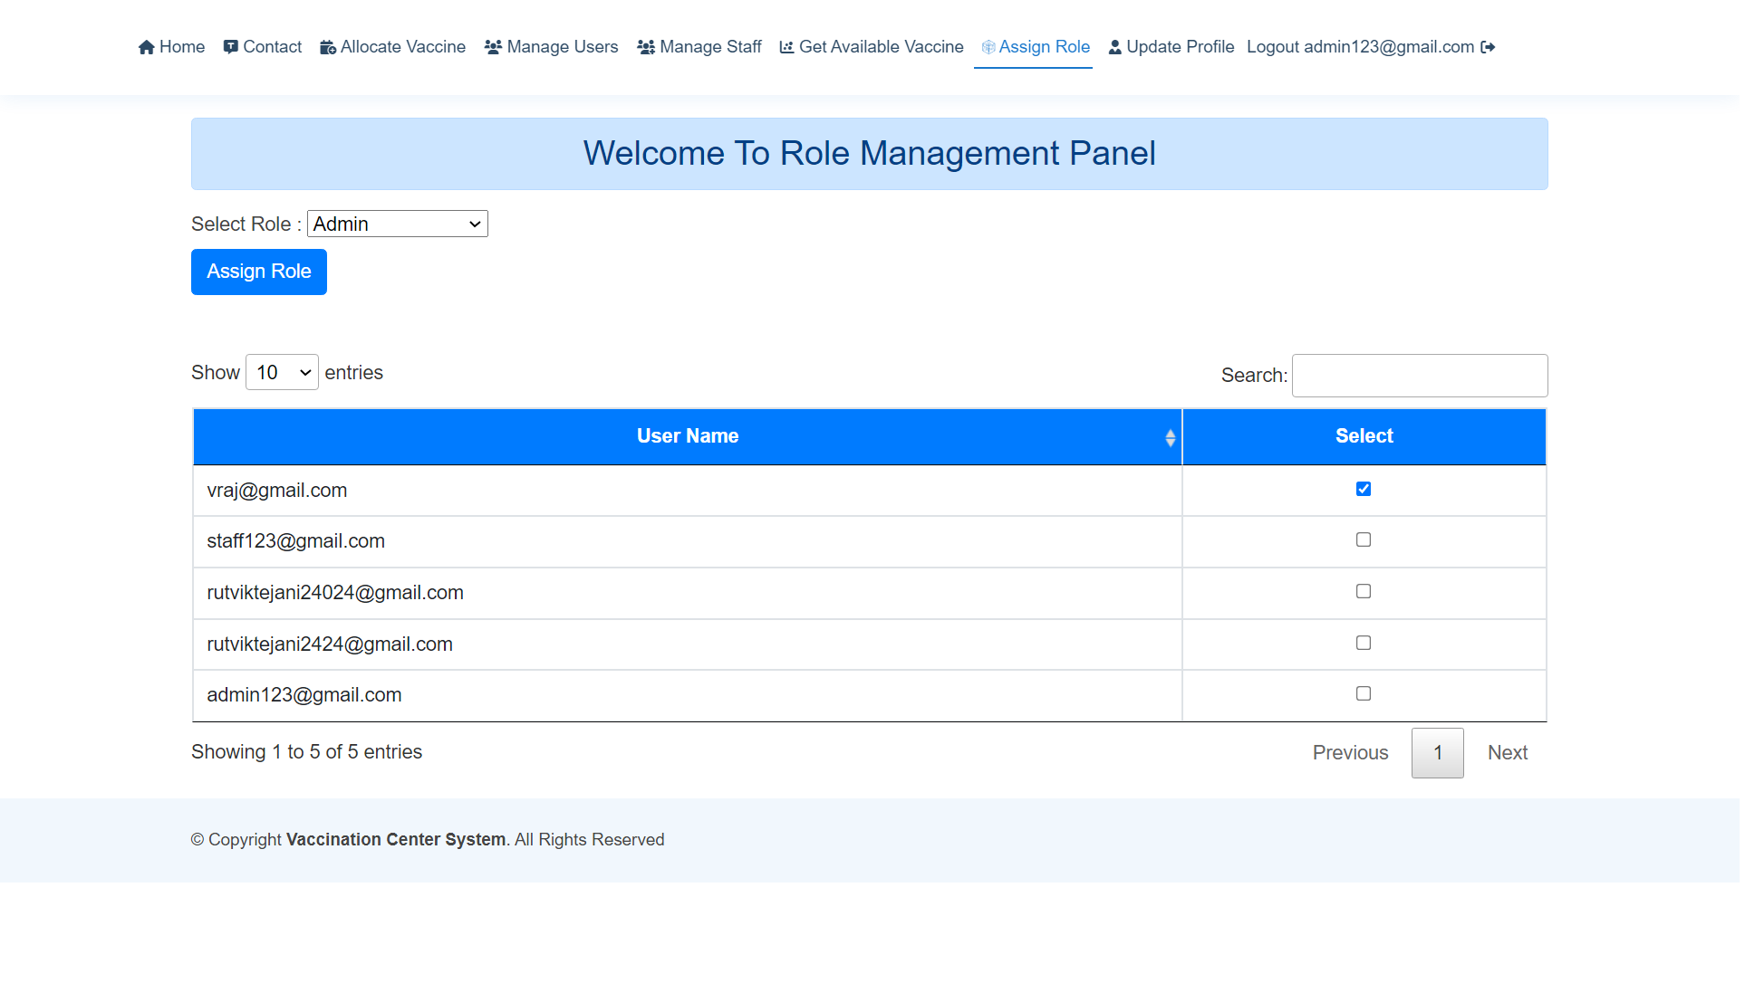

**Assign Role**



**7**

Chapter

**Software Testing**

* Testing is the process of examining an application to ensure it fulfils the requirements for which it was designed and meets quality expectations. In short, Testing is software quality assurance activity.
* The main objective of testing is to find yet an undiscovered error and at the same
* Time checking the quality and reliability of system. More importantly, testing ensure that the application meet customers’ expectations.
* Testing accomplished a variety of things, but most importantly it measures the quality of websites you are developing.
* This view presupposes there are defect in your website waiting to be discovered and this view is rarely disproved or even disputed.
* System testing makes logical assumptions that if all the part of the system is correct so that the goal will be successfully achieved. The system should be checked logically.
* Validations and cross checks should be implemented, avoiding duplications of records, which cause redundancy of data.
* **Unit Testing :**
  + The primary goal of unit testing is to take the smallest piece of testable web site in the application, isolate it from the remainder of the code, and determine whether it behaves exactly as you expect.
  + Each unit was tested separately before integrating them into modules to test the interfaces between modules for that prepare case.
  + It allows automation of the testing process, reduces difficulties of discovering error contained in more complex pieces of the application, and test coverage is often enhanced because attention is given to each unit.
  + In the web based application smallest testable unit is web page itself. So the web Pages of the site are to be unit tested. Each web page contains content, navigational links, and processing elements (script, event handlers, etc.). The testing will be driven by the content processing, and links contained in the site.
* **Integration Testing :**
* Integration testing is logical extension of unit testing. Integration testing takes its input modules that have been checked out by unit testing, group them in large aggregates, applied test define in an integration test plan to those aggregates, and delivers as its output the integration system ready for Web site testing.
* Integration testing is done for checking whether all modules are worked properly or not after integration.
* Purpose of Integration testing is to verify functional, performance and reliability requirements placed on major design items.
* Using dummy web pages it is checked that whether output of page will redirect to specific web page. After that regression testing strategy helps us to ensure that changes do not introduce unintended behaviour or additional errors.
* **Validation Testing :**
* After integration testing, web site is completely assembled as a package, interfacing error has been uncovered and corrected and the final series of the web site is tested. The validation succeeds when the web site functions in a manner that can be reasonably accepted by the client.
* Validation tests provide assurance that the web site as written meets all the requirements.
* In validation testing, requirement established as part of software requirements analysis are validated against the software that has been constructed.
* All validation criteria are tested. Validation testing provides the final assurance that software meets all functional, behavioural and performance requirements.
  + - In date entry user cannot insert incorrect date format, if user enter wrong date then it will display the error message.
    - In numeric field only enter numeric data otherwise display error message.
    - In text field only enter text data otherwise display error message.

**8**

Chapter

**Limitation and Future Scope of Enhancements References**

Limitation

Data security –provide high security to secure user data,like aadhar no,phno.

**FUTURE ENHANCEMENT**

We can enhance our services and try to available many type of vaccine in short time.

In Future, We can provide more medical field related service to make smart and speedy services.



**References**

All the needed information related to my project “**Vaccination Centre System”** was being clumped from the following sources:

**CSS**

<https://www.w3schools.com/w3css>

**Bootstrap**

<https://getbootstrap.com/>

**jQuery**

<http://jquery.com/>

<https://cdn.datatables.net/>

**Javascript**

<https://www.javascript.com/>